FUSIONCORE $v_{0}$
Phase 2 — Zero-Leakage Normalisation & Dataset Unification
Notebook 02 | Technical Deep-Dive Analysis
Author: Michele E. J. Maestrini


1. Abstract
This report presents a rigorous technical analysis of the zero-leakage preprocessing pipeline implemented in FusionCore v0, Phase 2 (Notebook 02). The pipeline operates on the NASA C-MAPSS turbofan engine degradation dataset (Saxena & Goebel, 2008) [1] and encompasses five principal engineering steps: (i) GroupShuffleSplit partitioning enforcing engine-boundary integrity; (ii) K-Means operating regime identification on the three-dimensional operational settings space; (iii) per-regime Z-score normalisation with exclusively train-derived parameters; (iv) Shewhart Statistical Process Control (SPC) chart validation anchored to P-F curve theory (Nowlan & Heap, 1978) [2]; and (v) unified dataset construction designated FD00u. Six programmatic gate criteria are applied as acceptance thresholds. All six gates pass on the executed run. Critical findings, statistical results, identified engineering trade-offs, and recommendations for Phase 3 are documented herein.

2. Dataset Loading, Corpus Statistics & RUL Target Construction

2.1 Corpus Statistics (Cells 3-6 — Load All Training Subsets)
The four C-MAPSS training subsets are loaded, and the piecewise-linear clipped Remaining Useful Life (RUL) [3] target is computed. The resulting corpus statistics are presented in Table 1.
Table 1 — C-MAPSS Training Corpus Statistics
Subset | Engines (N) | Rows | Max Cycle | Operational Complexity
FD001 | 100 | 20,631 | 362 | Single regime — sea-level ISA
FD002 | 260 | 53,759 | 378 | Six regimes — full flight envelope
FD003 | 100 | 24,720 | 525 | Single regime — sea-level ISA
FD004 | 249 | 61,249 | 543 | Six regimes — full flight envelope
TOTAL | 709 | 160,359 | 543 | —
The dataset exhibits pronounced class imbalance across subsets: FD004 contributes 38.2% of total rows, whilst FD001 contributes only 12.9%. This heterogeneity has direct implications for batch composition in gradient-based models and must be managed in Phase 3 feature engineering. The FD00u unification step addresses this at the dataset level but does not resolve within-batch sampling bias for sequential model training.

2.2 Piecewise-Linear Clipped RUL Target
The RUL target is constructed following the Heimes (2008) [4] formulation, with a plateau cap of RUL_cap = 125 cycles. The piecewise-linear function is defined as:
$$\text{RUL}\left(t\right) = min\left(R_{\text{cap}}, \max_{t'∈T_{u}}\left(t'\right) - t\right)$$
Where:
- $t$— current cycle index for engine unit $u$
- $T_{u}$ — the set of all observed cycles for unit $u$
- $\max_{t^{'}∈T_{u}}\left(t^{'}\right)$ — the terminal cycle (end-of-life cycle) for unit $u$
- $R_{\text{cap}}=125$ — the piecewise plateau cap (Heimes, 2008) [4]
This produces the piecewise behaviour:
$RUL\left(t\right)=\left\{\begin{aligned}R_{cap} if \left(\max_{T_{u}}-t\right)≥R_{cap} \\ \max_{T_{u}}-t if \left(\max_{T_{u}}-t\right)<R_{cap}\end{aligned}\right.$​​
The first case defines the incubation plateau — the region where the engine is healthy and degradation is below sensor detection threshold. The second case defines the linear countdown — where macroscopic degradation is active and RUL decreases monotonically to zero at end-of-life.
Physical justification: The plateau models the Paris' Law [5] crack initiation (incubation) phase — the period before macroscopic defect propagation is detectable by onboard sensors. Heimes (2008) demonstrated that uncapped RUL targets cause the loss surface to be dominated by healthy early-life data, suppressing gradient signal at the safety-critical terminal region. The cap ensures uniform gradient weighting across the engine's operational life.
Engineering note: The RUL cap of 125 is derived from the C-MAPSS dataset's statistical properties as reported in Heimes (2008) [4] and has become the de facto standard in the PHM benchmark literature. It does not correspond to a specific physical failure interval and should not be directly transferred to N-CMAPSS (v2 roadmap), which requires dataset-specific calibration of the incubation boundary.

2.3 Data Integrity Verification (Cell 7 — Head/Tail Inspection)
Head and tail inspection confirms four critical properties consistent with C-MAPSS simulation characteristics:
- FD001/FD003: $op1 ≈ ±0.004$ (Gaussian noise around sea-level ISA altitude), $op2 ≈ ±0.0005$ (near-zero Mach), $op3 = 100.$0 (fixed TRA). Sensor s1 (T2, Fan Inlet Temperature) is constant at 518.67 R — the ISA sea-level total temperature standard atmosphere value.
- FD002/FD004: op1 ranges 0–42 (simulation-internal altitude scale), op2 ranges 0–0.84 (Mach), op3 assumes discrete values of 60 and 100 (TRA setting). This confirms six discrete operating regimes, visible as discrete clustering in op-space.
- Terminal row $(RUL = 0)$ is present for each engine — confirming run-to-failure trajectories for all units. This is a necessary condition for supervised degradation model training.
- Columns s1, s5 (P2), s10 (epr), s16 (farB), s18 (Nf_dmd), s19 (PCNfR_dmd) exhibit near-zero variation in FD001/FD003 — consistent with Phase 1 EDA findings for dead-sensor identification. These are flagged for later regime-dead classification.

3. Iron Wall Protocol — GroupShuffleSplit Partitioning (Cells 8–9)

3.1 Methodological Rationale
The partitioning strategy addresses a critical leakage vector present in naïve random row-level splits. Turbofan degradation data is a multivariate time series indexed by (unit_id, cycle). A random row-level split probabilistically places early and late cycles from the same engine in both train and validation sets. The model can then implicitly recover the RUL label of a validation cycle by interpolating from adjacent training cycles of the same engine — a form of information leakage that inflates reported validation metrics without reflecting true generalisation performance.
GroupShuffleSplit (Pedregosa et al., 2011 — Scikit-learn) [6] enforces a hard engine-boundary constraint: all cycles belonging to a given unit_id are assigned exclusively to one partition. This preserves temporal sequence integrity and prevents the above interpolation leakage. The engine-level split is the minimum adequate unit for C-MAPSS; cycle-level stratification is neither necessary nor appropriate, as each engine constitutes a single fault trajectory.

3.2 Split Results
Table 2 — GroupShuffleSplit Results by Subset
Subset | Train Engines | Train Rows | Val Engines | Val Rows | Overlap | Val %
FD001 | 80 | 16,561 | 20 | 4,070 | 0 | 19.7%
FD002 | 208 | 43,464 | 52 | 10,295 | 0 | 19.4%
FD003 | 80 | 20,012 | 20 | 4,708 | 0 | 19.1%
FD004 | 199 | 49,294 | 50 | 11,955 | 0 | 19.5%
FD00u | 567 | 129,331 | 142 | 31,028 | 0 | ~19.3%
The row-level validation proportions (19.1%–19.7%) are slightly below the nominal 20% target due to engine-count discretisation. This is an expected artefact of group-level splitting and is not a pipeline defect — the proportions are within acceptable engineering tolerance. Critically, the programmatic overlap check (Cell 9) confirms zero engine ID intersection across all four subsets. The Iron Wall assert statement (Cell 9) constitutes a hard gate: if any overlap existed, execution would halt.
Leakage Risk: The engine-level split alone does not fully isolate the validation set from leakage through the normalisation parameters. If K-Means or Z-score parameters were fitted on the full dataset (including validation engines), their statistical fingerprints would contaminate the downstream feature space. The Iron Wall Protocol addresses this explicitly by freezing all parameters exclusively on the Internal Train partition before any transformation is applied.

3.3 Temporal Consistency Note
The GroupShuffleSplit operates on row indices, not explicitly on temporal order. Because each engine's cycles are contiguous in the source files, the split preserves complete engine trajectories. However, the resulting train/validation DataFrames have their row indices reset and are not sorted by (unit_id, cycle). Downstream model training pipelines must re-sort by (unit_id, cycle) if sequence-aware training (e.g., LSTM, Temporal Fusion Transformer) is intended in Phase 3. This is not a defect in Phase 2 but requires explicit handling at the Phase 3 feature engineering and model training boundaries.

4. Operating Regime Identification via K-Means Clustering (Cells 10–14)

4.1 Physical Motivation and Literature Context
C-MAPSS FD002 and FD004 simulations encompass six discrete flight operating conditions defined by combinations of altitude (op1), Mach number (op2), and Throttle Resolver Angle (op3). These operating conditions produce distinct thermodynamic equilibria across the engine gas-path. Sensor readings at high-altitude cruise ($op1 ≈ 42$, $op2 ≈ 0.84$) differ systematically from readings at sea-level ground idle ($op1 ≈ 0$, $op2 ≈ 0$) even for a new, healthy engine. Without regime isolation, these operating-point-driven sensor offsets dominate the signal space and suppress the comparatively smaller degradation-driven drift, reducing model sensitivity to incipient fault progression.
FD001 and FD003 operate exclusively at a single sea-level static condition $(op1 ≈ 0, op2 ≈ 0, op3 = 100)$ and therefore require no regime conditioning — a single regime $(K = 1)$ is assigned by construction. K-Means clustering on the three-dimensional operational settings space (op1, op2, op3) is applied to FD002 and FD004 exclusively, with $K = 6$ corresponding to the six discrete operating conditions present in the C-MAPSS simulation

4.2 K-Means Configuration and Fitting
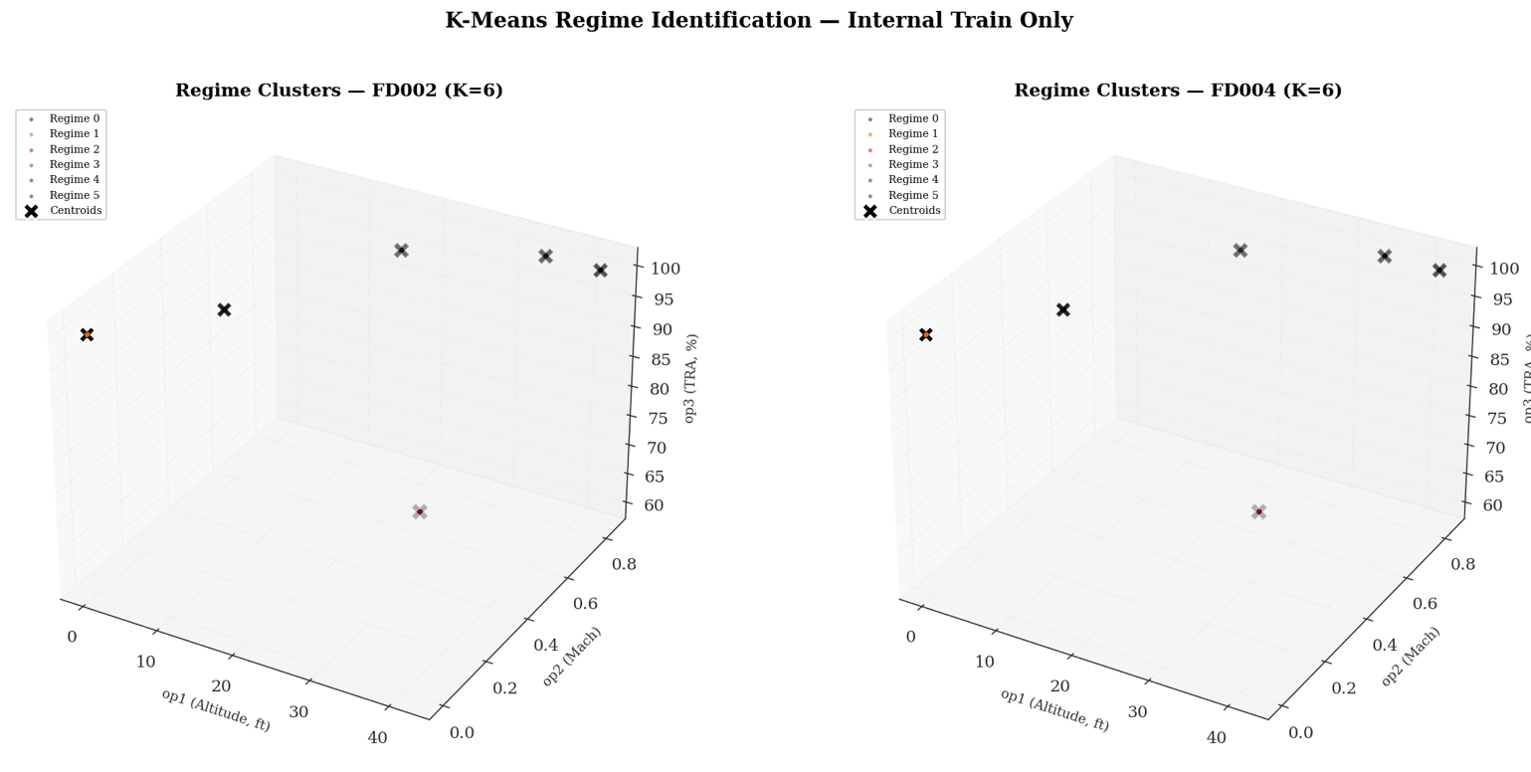
Figure 1 — 3D Scatter of Regime Clusters (FD002 / FD004)

Figure 1: The two panels in this figure confirm one of the most important architectural decisions of the Phase 2 pipeline: that the C-MAPSS operating conditions are discrete, geometrically separable states rather than a continuous operational cloud. Each coloured point in the three-dimensional space — defined by altitude (op1), Mach number (op2), and throttle setting (op3) — collapses to a single location, with no overlap between the six clusters in either subset. The K-Means centroids (marked ✕) sit precisely atop their respective data populations, confirming that the algorithm has identified physically meaningful flight conditions rather than arbitrary statistical partitions. The broader significance of this separability is that it validates the normalisation strategy that follows. Each cluster corresponds to a distinct thermodynamic operating state — sea-level ground idle at the left foreground, maximum-altitude cruise at the upper right, and the partial-throttle climb condition (the lone intermediate cluster distinguished by its reduced throttle setting of 60%) occupying its own isolated position in the lower middle of the space. Because these conditions are structurally distinct, the per-regime Z-score normalisation can reliably strip out the operating-point-driven sensor offsets and expose the comparatively subtler signal of engine degradation. The label ordering differs between FD002 and FD004 — what is Regime 0 in FD002 corresponds to Regime 5 in FD004 — but this is an expected consequence of independent centroid initialisation and has no bearing on the correctness of the normalisation. Each regime is self-contained.
Table 3 — K-Means Regime Configuration
Subset | K | Features | n_init | Physical Justification
FD001 | 1 | op1, op2, op3 | N/A | Sea-level static only — single operational condition
FD002 | 6 | op1, op2, op3 | 20 | Full flight envelope — six altitude/Mach/TRA combinations
FD003 | 1 | op1, op2, op3 | N/A | Sea-level static only — single operational condition
FD004 | 6 | op1, op2, op3 | 20 | Full flight envelope — six altitude/Mach/TRA combinations
n_init = 20 is defined as the project constant KMEANS_N_INIT and passed directly to the K-Means constructor. It controls how many times the K-Means algorithm is run in full, from a different random centroid initialisation — after all 20 runs complete, the solution with the lowest inertia (sum of squared distances from each point to its assigned centroid) is retained as the final model. This is necessary because K-Means is sensitive to its starting centroid positions; a poor initialisation can cause convergence to a local minimum rather than the global optimum. At 20 initialisations, this is materially above the Scikit-learn default of 10, reducing sensitivity to centroid initialisation variance. Given the well-separated nature of the six C-MAPSS operating conditions — discrete simulation inputs rather than continuous operational data — the six regimes are geometrically separable, and K-Means converges reliably for $K = 6$ on this dataset. KMEANS_N_INIT = 20 is therefore a defensible engineering precaution rather than a strict requirement.

4.3 K-Means Centroids — Physical Validation
Table 4 presents the fitted K-Means centroids for FD002 and FD004. The centroid coordinates correspond directly to the six discrete operating conditions used in the C-MAPSS simulation framework.
The regime label ordering differs between FD002 and FD004 (e.g., Regime 0 in FD002 is the 42,000 ft condition whilst Regime 5 in FD004 occupies the same physical condition). This is an expected consequence of random centroid initialisation and does not affect normalisation correctness — each regime is self-contained and its associated Z-score parameters are derived independently from its own subset of Internal Train rows. Downstream modelling must treat regime_id as a nominal identifier, not an ordinal quantity with physical meaning.

Table 4 — K-Means Centroids with Physical Interpretation
Regime | op1 — Altitude | op2 — Mach | op3 — TRA | Inferred Flight Phase
FD002 — R0 | 42.003 | 0.8405 | 100.0 | Max-altitude cruise (top-of-climb)
FD002 — R1 | 0.002 | 0.0005 | 100.0 | Sea-level ground run / idle
FD002 — R2 | 25.003 | 0.6205 | 60.0 | Mid-altitude climb (partial TRA)
FD002 — R3 | 10.003 | 0.2505 | 100.0 | Low-altitude segment
FD002 — R4 | 20.003 | 0.7005 | 100.0 | Mid-altitude segment
FD002 — R5 | 35.003 | 0.8405 | 100.0 | High-altitude segment
FD004 — R0 | 35.003 | 0.8405 | 100.0 | High-altitude segment
FD004 — R1 | 0.002 | 0.0005 | 100.0 | Sea-level ground run / idle
FD004 — R2 | 25.003 | 0.6205 | 60.0 | Mid-altitude climb (partial TRA)
FD004 — R3 | 20.003 | 0.7005 | 100.0 | Mid-altitude segment
FD004 — R4 | 10.003 | 0.2505 | 100.0 | Low-altitude segment
FD004 — R5 | 42.003 | 0.8405 | 100.0 | Max-altitude cruise (top-of-climb)

4.4 Regime Distribution in Internal Train
Table 5 — Regime Row Distribution in Internal Train
Subset | Regime | Train Rows | % of Subset Train
FD002 | 0 (alt 42, Mach 0.84) | 10,857 | 25.0%
FD002 | 1 (sea-level) | 6,507 | 15.0%
FD002 | 2 (alt 25, Mach 0.62) | 6,450 | 14.8%
FD002 | 3 (alt 10, Mach 0.25) | 6,572 | 15.1%
FD002 | 4 (alt 20, Mach 0.70) | 6,535 | 15.0%
FD002 | 5 (alt 35, Mach 0.84) | 6,543 | 15.1%
FD004 | 0 (alt 35, Mach 0.84) | 7,375 | 15.0%
FD004 | 1 (sea-level) | 7,447 | 15.1%
FD004 | 2 (alt 25, Mach 0.62) | 7,371 | 15.0%
FD004 | 3 (alt 20, Mach 0.70) | 7,307 | 14.8%
FD004 | 4 (alt 10, Mach 0.25) | 7,385 | 15.0%
FD004 | 5 (alt 42, Mach 0.84) | 12,409 | 25.2%

A notable imbalance exists in both multi-regime subsets: FD002 Regime 0 (25.0%) and FD004 Regime 5 (25.2%) each account for approximately double the row count of the remaining five regimes. This corresponds to the high-altitude cruise condition ($op1 ≈ 42$, $op2 ≈ 0.84$) and reflects the simulated mission profile where engines spend proportionally more time at cruise altitude. This imbalance is physically grounded and expected. However, it has a material statistical consequence: the Z-score parameters $(μ, σ)$ for the over-represented regime are computed from approximately twice the sample size of the under-represented regimes, yielding tighter parameter confidence intervals for Regime 0/5 than for the balanced regimes.
Critical observation for Phase 3: The regime-level row imbalance means that any RUL model trained on FD00u will have unequal effective sample density across operating conditions. The cruise regime (dominant regime) will drive the majority of gradient updates in a naïvely trained model. Weighted sampling or loss-weighting by regime may be warranted to prevent the model from implicitly specialising in cruise-condition RUL estimation at the expense of other flight phases.

4.5 Serialisation of Frozen Models
The K-Means models for FD002 (174,999 bytes) and FD004 (198,319 bytes) are serialised via joblib.dump() to the regime_dictionary/ directory. The size differential is consistent with FD004 having a marginally larger feature matrix during fitting. The serialisation pattern is correct for production deployment: the frozen model is the single source of truth for regime assignment across all downstream phases. Any re-fitting of K-Means would invalidate all derived normalisation parameters.
Table 6 — Serialised Artefacts in Regime Dictionary (Cell 18)
Artefact | Size (bytes) | Purpose
kmeans_FD002.pkl | 174,999 | Frozen regime assignment for FD002 train, val, and test inference
kmeans_FD004.pkl | 198,319 | Frozen regime assignment for FD004 train, val, and test inference
regime_zscore_params.pkl | 31,755 | Per-regime $μ,$ $σ$ for all four subsets — 24 columns × n_regimes

5. Per-Regime Z-Score Normalisation (Cells 15–19)

5.1 Mathematical Formulation
$$z_{x,r}=\frac{x-μ_{x,r}^{\text{train}}}{σ_{x,r}^{\text{train}}}$$
Where:
- $x$ — raw sensor observation for sensor $x$ within regime $r$
- $μ_{x,r}^{\text{train}}$ — arithmetic mean of sensor $x$ computed exclusively from Internal Train rows assigned to regime $r$
- $σ_{x,r}^{\text{train}}$ — standard deviation of sensor $x$ computed exclusively from Internal Train rows assigned to regime $r$
- $z_{x,r}$ — normalised sensor value expressed in units of standard deviations from the regime-specific healthy baseline

With the near-zero sigma guard applied:
$$σ_{x, r}^{train}= \left\{\begin{matrix}σ_{x, r}^{train} if σ_{x, r}^{train}≥\sqrt{τ} \\ 1.0 if σ_{x, r}^{train}<\sqrt{τ} \end{matrix}\right.$$
Where $τ=1×{10}^{-5}$ is the variance threshold defined as the project constant VARIANCE_THRESHOLD, giving a sigma floor of $\sqrt{τ}≈0.00316$.
For each sensor $x$ in NORMALISE_COLS and each regime $r$, the normalised value is computed as:
- $z = 0$ represents the healthy thermodynamic baseline for that sensor within that specific operating regime.
- Departures from $z = 0$ represent deviations from the healthy operating locus — the signal of interest for degradation detection.
- The per-regime conditioning removes the dominant operating-point effect, exposing the comparatively weaker degradation-driven drift within each flight phase.
NORMALISE_COLS encompasses all 21 sensors and all 3 operational settings (24 total columns). Normalising the operational settings columns is operationally redundant after regime assignment (they become near-zero by construction within each regime), but it is consistent and ensures no unnormalised columns enter the downstream feature matrix.

5.2 Near-Zero Sigma Guard
The variance threshold: $τ=1×{10}^{-5}$ is defined as the project constant VARIANCE_THRESHOLD, giving a sigma floor of $\sqrt{τ}≈0.00316$.
If a sensor's within-regime standard deviation falls below this floor, $σ$ is replaced with 1.0. This guard prevents division-by-zero for sensors that are physically constant within a given regime. The resulting transformation:
$$z=\frac{x-μ}{1.0}=x-μ$$
preserves the offset from the regime's healthy baseline without amplifying numerical noise.
The sigma floor derivation $\sqrt{τ}≈0.00316$ is internally consistent with Phase 1: $τ=1×{10}^{-5}$ was pre-specified in Phase 1 (Notebook 01, Cell 3) as the dead-sensor detection boundary in variance space, making $\sqrt{τ}$ the corresponding boundary in standard deviation space.

5.3 Guarded Sensor Summary
Table 7 — Per-Regime Near-Zero Sigma Guard Summary
Subset | Regime | # Guarded Cols | Guarded Sensors
FD001 | 0 (single) | 10 | op1, op2, op3, s1, s5, s6, s10, s16, s18, s19
FD002 | 0 | 9 | op1, op2, op3, s1, s5, s10, s16, s18, s19
FD002 | 1 (sea-level) | 10 | op1, op2, op3, s1, s5, s6, s10, s16, s18, s19
FD002 | 2 | 9 | op1, op2, op3, s1, s5, s10, s16, s18, s19
FD002 | 3 | 9 | op1, op2, op3, s1, s5, s10, s16, s18, s19
FD002 | 4 | 7 | op1, op2, op3, s1, s5, s18, s19
FD002 | 5 | 10 | op1, op2, op3, s1, s5, s6, s10, s16, s18, s19
FD003 | 0 (single) | 8 | op1, op2, op3, s1, s5, s16, s18, s19
FD004 | 0–5 (all) | 7–9 | Variable — core set: op1, op2, op3, s1, s5, s18, s19
The consistency of the guarded set across regimes confirms that the dead sensors (s1, s5, s18, s19) are physically constant both within regimes and globally. The op1, op2, and op3 columns entering the guard is expected: within a given regime cluster, the operational settings converge to within a narrow band of the centroid by K-Means construction, producing near-zero within-regime variance.
The regime-variable guarded set (e.g., s6 and s10 are guarded in some FD002 regimes but not others) merits attention. Sensor s10 (Engine Pressure Ratio, EPR) is a derived quantity that can exhibit regime-specific behaviour where the ratio becomes near-constant at certain flight conditions. This does not indicate a sensor fault — it reflects the thermodynamic coupling between operating condition and the EPR measurement range.

5.4 Validation Transform Application
The apply_regime_zscore() function is defined in Cell 17 and accepts three arguments: the DataFrame to transform, the frozen parameters dictionary — which receives regime_params[subset] at the call site — and the list of columns to normalise. All normalisation columns are cast to float64 prior to transformation to prevent dtype incompatibility when overwriting integer-typed operational setting columns with float Z-score values. The transformation is then applied per regime by masking rows on regime_id and subtracting the frozen p["mu"] before dividing by the frozen p["sigma"], where both parameters were computed exclusively from Internal Train rows in Cell 16.
The function is called twice per subset — once for the Internal Train partition and once for the Internal Validation partition — passing the identical frozen parameter set to both. No $μ$ or $σ$ is computed from the validation partition at any point in the pipeline. This is confirmed by the Cell 17 printed output, which states explicitly: "Parameters were fitted on Internal Train ONLY. Internal Validation was TRANSFORMED only — never used for parameter estimation." This transform-only application to the validation partition is the defining property of a leakage-free preprocessing protocol.

5.5 Gate 2 — Z-Score Parameter Physical Validation (Cell 19)
Gate 2 validates the fitted Z-score parameters for three key sensors — s4 (T50/EGT), s7 (P30 HPC Outlet Pressure), and s9 (Nc Core Speed) — across all regime and subset combinations, confirming that $μ$ is finite and non-NaN and $σ$ is strictly positive and finite. All 42 parameter sets pass. Two analytically significant observations arise from the output.

5.5.1 Physical Consistency of $μ$ Across Regimes
The $μ$ values vary systematically and in a thermodynamically correct direction across regimes. Taking FD002 as the representative example, the sea-level regime (Regime 1) produces the highest EGT mean $(μ = 1408.93°R)$ and highest HPC outlet pressure $(μ = 553.35 psia)$, whilst the partial-TRA climb regime (Regime 2, $TRA = 60$) produces the lowest EGT $(μ = 1050.37°R)$ and lowest P30 $(μ = 175.42 psia)$. This ordering is thermodynamically correct — reduced throttle and lower ambient pressure at altitude both lower combustor exit temperatures and compressor delivery pressures. This systematic variation directly validates that K-Means has correctly isolated the six physical operating conditions rather than producing arbitrary statistical partitions.

5.5.2 $σ$ Discrepancy for s7 (P30) Between Fault Mode Families
The within-regime standard deviation for s7 at the sea-level condition differs materially between subset pairs:
Table 8 — s7 (P30) Within-Regime σ by Fault Mode Family
Subset | Regime | Fault Mode | s7 $σ$(psia)
FD001 | 0 | HPC degradation only | 0.8778
FD002 | 1 | HPC degradation only | 0.8684
FD003 | 0 | HPC + fan degradation | 3.4447
FD004 | 1 | HPC + fan degradation | 3.4858
FD003 and FD004 exhibit s7 $σ$ values approximately four times larger than FD001 and FD002 at the equivalent sea-level operating condition. FD001 and FD002 simulate HPC degradation exclusively, whilst FD003 and FD004 simulate simultaneous HPC and fan degradation. The additional fan fault mode introduces a secondary pressure disturbance that propagates through the gas-path and manifests as increased within-regime variability in HPC outlet pressure. This $σ$ differential is therefore physically grounded in the fault mode difference between the subset pairs and is not a pipeline artefact.
Critical observation for Phase 3: The $σ$ differential carries a direct consequence for FD00u: the normalised z-space for s7 has materially different sensitivity characteristics between the two fault mode families. A unit deviation in normalised s7 represents a 0.878 psia excursion in FD001/FD002 but a 3.445 psia excursion in FD003/FD004. Any model trained on the unified FD00u dataset must therefore implicitly reconcile two different physical scales for s7 under a single normalised feature — a source of within-feature heterogeneity that is not resolved by the current pipeline and warrants explicit attention in Phase 3 model design.

6. Shewhart Statistical Process Control Charts — Population-Level Gate 3 (Cells 21–23)

6.1 Theoretical Foundation
Shewhart’s SPC framework (Shewhart, 1931) [7] provides the empirical bridge between the normalised z-space and the P-F curve construct of Nowlan & Heap (1978) [2]. In the normalised sensor space, the Shewhart control chart operationalises the following health-state classification scheme:
Table 9 — Shewhart Control Zone Mapping to PHM Health States
Zone | Threshold | SPC Interpretation | PHM Interpretation
Healthy | $$|z| < 2.0$$ | In-control — process within $2σ$ | Engine in incubation phase; no measurable degradation
Warning (UWL/LWL) | $$2.0 ≤ |z| < 3.0$$ | Warning — statistically unusual | Approaching Potential Failure Point P on P-F curve
Action (UCL/LCL) | $$|z| ≥ 3.0$$ | Out-of-control — action required | Functional Failure imminent — within P-F interval
The UCL/LCL thresholds at $z = ±3$ correspond to the 3-sigma rule where approximately 99.73% of in-control process observations are expected to fall within the control limits under a normal distribution assumption. The UWL/LWL at $z = ±2$ correspond to the 95.45% probability bounds. The application of these thresholds in PHM rests on the assumption that the normalised healthy-engine sensor distribution is approximately Gaussian — a property empirically justifiable for the thermodynamic sensors in C-MAPSS given their simulation origins. Representative engine Shewhart charts for sensors s4, s7, and s9 are generated in Cell 22.6.2 Gate 3 — Population-Level P-F Interval Validation (Cell 23)
Gate 3 is implemented as a population-level validation across all engines in the Internal Train partition — not a single representative engine. The methodology proceeds in four sequential steps, grounded in P-F curve theory (Nowlan & Heap, 1978) [2].

6.2.1 Step 1 — Population-Level Breach Detection
For every engine u in the Internal Train partition, the first cycle at which s4 (EGT) breaches the UWL threshold $|z| > 2$ is recorded as $c_{breach}\left(u\right)$. Engines that never breach are classified separately as non-breaching. The breach rate across the population is:
$$\text{Breach Rate}= \left|\frac{\{u:c_{\text{breach}}(u)\text{ is defined}\}}{U}\right|$$

Table 10 — Step 1: Population Breach Detection Results (s4 / T50)
Subset | Engines (N) | Breaching | Non-Breaching | Breach Rate
FD001 | 80 | 80 | 0 | 100.0%
FD002 | 208 | 208 | 0 | 100.0%
FD003 | 80 | 80 | 0 | 100.0%
FD004 | 199 | 199 | 0 | 100.0%
Overall | 567 | 567 | 0 | 100.0%
A 100% breach rate confirms that s4 EGT is a universal degradation indicator across the entire Internal Train engine population. Every engine, regardless of trajectory length or operating condition, produces at least one UWL exceedance before end of life. This is the most favourable possible result for the breach rate condition and validates that the normalised z-space correctly exposes the degradation signal.

6.2.2 Step 2 — Normalisation to RUL at Breach — The P-F Interval
Raw breach onset cycles are not directly comparable across engines with different total trajectory lengths. The meaningful quantity is the Remaining Useful Life at the moment of first breach — the P-F interval in Nowlan & Heap (1978) [2] terminology. This is the maintenance lead time available to a scheduler from the moment the warning signal is first detected:
$${\text{RUL}}_{\text{breach}}(u)=c_{\text{max}}(u)-c_{\text{breach}}(u), {\text{RUL}}_{\text{breach}}(u)=Δ_{PF}(u)$$
Where $c_{\text{max}}(u)$ is the terminal cycle $(RUL = 0)$ and $c_{\text{breach}}(u)$ is the first UWL breach cycle for engine $u$. $Δ_{PF}(u)$ is therefore the time between the Potential Failure point P (first detectable EGT warning, $|z| > 2$) and the Functional Failure point F (end of life, RUL = 0).
Table 11 — Step 2: P-F Interval Descriptive Statistics (cycles)
Subset | n | Mean $Δ_{PF}$ | Std Dev | Min | Max
FD001 | 80 | 84.9 | 87.7 | 1 | 282
FD002 | 208 | 106.5 | 92.6 | 6 | 361
FD003 | 80 | 73.6 | 104.4 | 2 | 449
FD004 | 199 | 102.0 | 114.4 | 1 | 464
Overall | 567 | 97.2 | 102.2 | 1 | 464
The minimum P-F interval of 1 cycle in both FD001 and FD004 indicates that at least one engine first breaches the UWL on its penultimate cycle — providing effectively zero scheduling lead time. The maximum of 464 cycles (FD004) represents an engine triggering the warning signal nearly 500 cycles before failure. The range of 1 to 464 cycles already signals substantial population heterogeneity before the percentile analysis is applied.

6.2.3 Step 3 — Percentile Distribution of P-F Intervals
The P-F interval distribution characterises the “schedulability” of condition-based maintenance. The Coefficient of Variation (CV) is the normalised measure of spread — dimensionless and comparable across subsets with different mean trajectory lengths:
$${\tilde{c}}_{50}=\text{median}\left({\text{RUL}}_{\text{breach}}\right), { \tilde{c}}_{10}=P_{10}\left({\text{RUL}}_{\text{breach}}\right),{ \tilde{c}}_{90}=P_{90}\left({\text{RUL}}_{\text{breach}}\right) \\ IQR=P_{75}-P_{25} \\ \text{CV}=\frac{σ_{{\text{RUL}}_{\text{breach}}}}{μ_{{\text{RUL}}_{\text{breach}}}}$$
All four subsets exhibit CV substantially above 0.50 (Table 12), ranging from 0.869 (FD002) to 1.419 (FD003). This is the analytically significant finding of Gate 3 and is addressed in full in Section 6.3.
Table 12 — Step 3: P-F Interval Percentile Distribution (cycles)
Subset | P50 (Median) | P10 | P25 | P75 | P90 | IQR | CV
FD001 | 33.0 | 8.9 | 17.8 | 178.0 | 210.2 | 160.2 | 1.033
FD002 | 68.0 | 15.0 | 23.0 | 182.0 | 233.3 | 159.0 | 0.869
FD003 | 25.5 | 9.9 | 17.0 | 56.8 | 242.6 | 39.8 | 1.419
FD004 | 36.0 | 13.0 | 22.0 | 192.0 | 291.0 | 170.0 | 1.123
Overall | 36.0 | 13.0 | 20.5 | 174.5 | 257.2 | 154.0 | 1.052

Figure 2: This is the most operationally consequential output of the Phase 2 pipeline. It translates a statistical property of the normalised sensor space into a direct statement about what is — and is not — achievable with a conventional single-threshold maintenance alert.

The left panel shows how the 567 Internal Train engines are distributed by the time remaining before end-of-life at the moment the EGT first triggers its warning threshold. The story it tells is stark: the largest single group of engines enters alert status with fewer than 30 cycles remaining. For a commercial operation requiring a minimum turnaround of 20 cycles to respond, book a hangar slot, and provision parts, a significant fraction of the engine population would reach functional failure before any intervention could be completed.
- The right panel reinforces this with box plots that reveal just how wide the spread is across all four subsets. FD002 has the most favourable profile — its median P-F interval sits at 68 cycles, and its distribution is the broadest in the upper direction, meaning that many of its engines provide a generous warning window. FD003 presents the most challenging picture: the median falls to 25.5 cycles, the box is compressed, and a cluster of high-value outliers extends to 450 cycles — a bimodal population where some engines give barely any warning and others give far more than could practically be used. The dashed reference line at 30 cycles marks the minimum operationally actionable threshold; the extent to which each distribution straddles this line defines the maintenance scheduling problem that Phase 3 modelling must resolve.
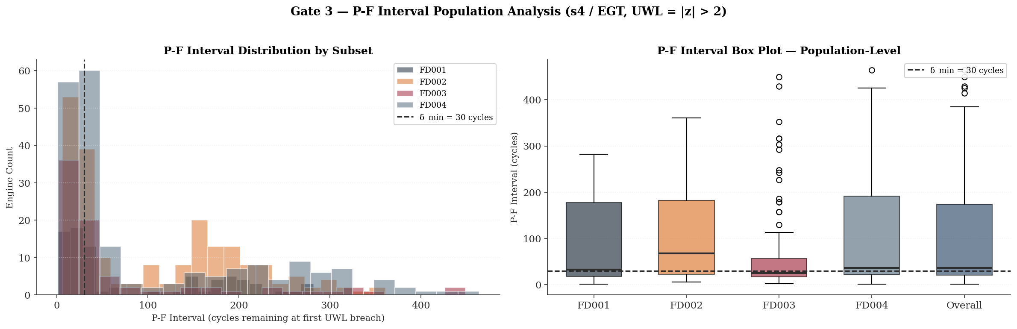
Figure 2 — Percentile Distribution of P-F Intervals
The conclusion from this figure is not that the pipeline or the signal is flawed — every single engine in the dataset did trigger the warning — but that a single fixed alert threshold cannot serve the full diversity of the engine population. This is the quantitative justification for a probabilistic RUL estimator in Phase 3.

6.2.4 Step 4 — Gate Assertion Structure
Gate 3 in Cell 23 distinguishes between HARD conditions, which must pass to allow the pipeline to proceed, and an ADVISORY condition, which characterises the quality of the maintenance signal without blocking execution:
$$\text{Gate 3 PASS }⟺ \left\{\begin{aligned}\text{Breach Rate}≥0.80 \\ {\tilde{c}}_{50}≥δ_{min}=30 cycles \\ \text{CV}≤δ_{\text{CV}}=0.50 \end{aligned}\right.$$
The thresholds are domain-calibrated, not statistical conventions: the 80% minimum breach rate reflects the minimum acceptable coverage of the engine population by the s4 EGT degradation signal; the 30-cycle minimum median P-F interval reflects the minimum operationally actionable maintenance lead time given realistic slot-booking and parts-provisioning lead times in commercial MRO operations; and the CV threshold of 0.50 defines the boundary above which a single fixed maintenance horizon becomes operationally unreliable.

Table 13 — Gate 3: Assertion Results (pooled across all subsets)
Condition | Type | Threshold | Pooled Result | Status
Breach Rate $≥ 80\%$ | HARD | $$≥ 80\%$$ | 100.0% | ✓ PASS
Median ${\text{Δ}}_{\text{PF}} ≥ 30$ cycles | HARD | $≥ 30$ cycles | 36.0 cycles | ✓ PASS
$$CV\left(Δ_{PF}\right)≤0.50$$ | ADVISORY | $$≤ 0.50$$ | 1.052 | ⚠ WIDE SPREAD
Gate 3 result: ✓ PASS (with Advisory — CV = 1.052 exceeds 0.50 threshold)

6.3 Maintenance Scheduling Interpretation — Narrow vs Wide P-F Interval Spread
The CV advisory result is the most operationally significant output of Gate 3 and requires detailed interpretation grounded in P-F curve theory (Nowlan & Heap, 1978) [2]. The two contrasting scenarios — narrow spread and wide spread — have materially different implications for condition-based maintenance schedulability.

6.3.1 The Narrow-Spread Case — Operationally Favourable
A narrow P-F interval distribution $(CV < 0.50)$ would indicate that the time between first UWL breach and engine functional failure is statistically consistent across the engine population. Taking a hypothetical example: median = 85 cycles, P10 = 65 cycles, P90 = 105 cycles. When a monitoring system detects the first UWL breach in s4, functional failure will occur within approximately 65–105 cycles for 80% of engines. A maintenance action scheduled at $c_{breach} + 50$ cycles would reliably precede failure for the overwhelming majority of the population. This is the minimum condition for condition-based maintenance to be operationally credible — the scheduler can plan a slot within the P-F interval with high confidence that the slot will not fall after functional failure has already occurred. Narrow spread also confirms that the underlying physical mechanism — blade tip clearance growth, hot-section fouling, HPT efficiency loss — progresses at a statistically homogeneous rate across engines, producing a predictable warning window.

6.3.2 The Wide Spread Case — The Actual Result
The actual results confirm wide spread across all subsets (CV: 0.869 to 1.419, overall CV = 1.052). The per-subset P10 and P90 values expose the operational consequences directly:
Table 14 — Per-Subset Maintenance Scheduling Consequences of Wide P-F Spread
Subset | Median $Δ_{PF}$ | P10 (cy) | P90 (cy) | AOG Risk (P10-tail) | Over-Maint. Risk (P90-tail)
FD001 | 33 | 9 | 210 | Failure within 9 cy of first breach | 200+ cy early removal if scheduled conservatively
FD002 | 68 | 15 | 233 | Failure within 15 cy of first breach | 220+ cy early removal if scheduled conservatively
FD003 | 26 | 10 | 243 | Failure within 10 cy of first breach | 230+ cy early removal if scheduled conservatively
FD004 | 36 | 13 | 291 | Failure within 13 cy of first breach | 270+ cy early removal if scheduled conservatively
The P10-tail engines — those with P-F intervals of 9 to 15 cycles — represent the AOG risk population. If a commercial MRO operation requires a minimum of 20 cycles to respond to an unscheduled maintenance alert, book a hangar slot, and provision the necessary parts, then P10-tail engines will reach functional failure before any intervention is possible. The expected loss $(E[L])$ from this tail is:
$$E[L]=P\left(Δ_{PF}<lead_{time}\right)×Cost_{AOG}$$
The P90-tail engines — those with P-F intervals of 210 to 291 cycles — represent the over-maintenance risk population. If the scheduling policy is set conservatively to protect against the P10-tail, P90-tail engines will be removed from service 200 to 280 cycles before they would have reached functional failure. Wide spread therefore forces an irresolvable trade-off between AOG risk and over-maintenance cost under any single fixed scheduling horizon. This trade-off is an intrinsic property of the s4 EGT signal at the UWL threshold across this engine population — not a consequence of the maintenance policy design.
Wide spread therefore forces a fundamental trade-off:

$${\text{Cost}}_{\text{total}}=P(\text{AOG})×{\text{Cost}}_{\text{AOG}}+P(\text{over-maintenance})×{\text{Cost}}_{\text{early-removal}}$$
6.3.3 Phase 3 Modelling Implications
The wide P-F interval spread carries three direct implications for Phase 3 model design. First, the P-F interval must be modelled as a random variable with explicit uncertainty bounds rather than a fixed scheduled maintenance horizon. A survival analysis framework — for example, a Cox Proportional Hazards model [8] [9] — can estimate $P(failure within k cycles | current z-score trajectory)$and provide a probabilistic scheduling recommendation rather than a binary alert. Second, the CV disparity between subsets (FD002 CV = 0.869 vs FD003 CV = 1.419) suggests that the fault mode family difference — HPC-only degradation versus HPC plus fan degradation — materially affects the predictability of the EGT warning window; UWL threshold recalibration per fault mode family warrants investigation. Third, a multivariate health index combining s4 with s7 (P30) and s9 (Nc) — the three sensors validated in Gate 2 — may produce a more consistent P-F interval distribution by capturing multiple degradation pathways simultaneously.
Advisory: The wide P-F interval spread (overall $CV = 1.052$) means that a single fixed maintenance horizon after first UWL breach in s4 EGT would not reliably capture all engines within their operationally actionable window. This does not invalidate the normalisation pipeline or the s4 signal — it characterises the limits of a univariate threshold-based scheduling policy and defines the minimum capability requirement for the Phase 3 RUL prediction model.

7. Dataset Unification — FD00u Construction (Cells 24–29)

7.1 Unification Rationale and Architecture
Following per-regime normalisation, all four subsets share a common z-space where $z = 0$ represents the within-regime healthy baseline for each sensor. The subsets can be concatenated because the normalisation has removed the operating-regime-specific offsets that would otherwise create distribution shift between subsets. The unified dataset FD00u enables models to train on the full corpus of 160,359 rows and 709 engines, rather than separate per-subset models.

Figure 3: This figure presents the complete data flow of the Phase 2 pipeline and should be read as the definitive reference for how information does — and does not — move between the training, validation, and test populations.
The story begins on the left with the split. All 709 engines are divided by engine identity: 80% flow into the Internal Train partition and 20% into Internal Validation, with the Official Test set held entirely apart. The critical constraint — annotated in red as "NO DATA FLOW" — is that neither the validation nor the test partition contributes any statistical information to what happens next.
- In the centre of the figure, the zero-leakage zone contains the only stage at which parameters are learned: K-Means clustering identifies the operating regimes from Internal Train data, and per-regime means and standard deviations are computed from Internal Train data alone. These parameters are then locked inside the Frozen Regime Dictionary, depicted with a padlock — once computed, they are immutable.
- From that point forward, the dictionary functions purely as a transformation tool. Its parameters flow outward — shown as dashed arrows — to normalise all three data populations using identical, pre-frozen statistics. The validation and test sets are transformed, never consulted. This is the defining characteristic of a leakage-free protocol: the holdout data has no influence on the feature space it will eventually be evaluated against.
- The final stage on the right shows the four normalised subsets converging into a single unified dataset. Because every subset has been referenced to its own regime-specific healthy baseline, the $z = 0$ value now carries the same physical meaning regardless of which subset, operating condition, or fault mode produced the observation. That shared reference frame is what makes a unified training corpus scientifically defensible.
Figure 3 — Unification Architecture
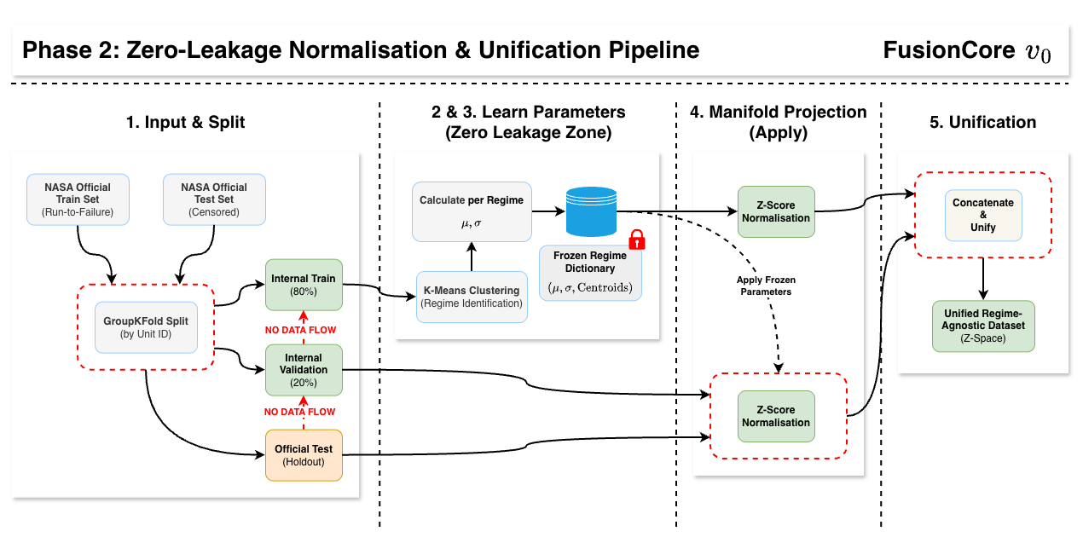
Table 15 — FD00u Unified Dataset Statistics
Partition | Rows | Engines | Subsets | Columns
FD00u_train | 129,331 | 567 (246 unique unit_id) | FD001+002+003+004 | 30 (original 28 + regime_id + subset_origin)
FD00u_val | 31,028 | 142 (93 unique unit_id) | FD001+002+003+004 | 30

Note on unit_id ambiguity: The original C-MAPSS subsets each have unit_id ranging from 1 to N (N=100, 260, 100, 249). After concatenation, unit_id is no longer globally unique — e.g., $unit_id=1$ exists in all four subsets. The subset_origin column resolves this ambiguity, but any downstream operation that groups by unit_id alone (e.g., sequence padding, trajectory-level aggregation) must also condition on subset_origin. Failure to do so is a silent data corruption error that would produce mixed-engine trajectories.

7.2 Descriptive Statistics — Normalised Sensor Space
Table 16 presents the descriptive statistics for all 21 normalised sensors in FD00u_train. The sensor taxonomy is derived from Gate 5 variance audit results.
Table 16 — FD00u Normalised Sensor Descriptive Statistics
Sensor | Physical Quantity | $μ$ (FD00u) | $σ$ (FD00u) | Min | Max | Classification
s1 | T2 — Fan Inlet Temp | 0.0000 | 0.0000 | 0.0000 | 0.0000 | REGIME-DEAD
s2 | T24 — LPC Outlet Temp | 0.0000 | 0.9999 | -3.741 | 5.088 | ACTIVE
s3 | T30 — HPC Outlet Temp | 0.0000 | 0.9999 | -3.588 | 4.342 | ACTIVE
s4 | T50 — LPT Outlet (EGT) | -0.0000 | 0.9999 | -3.062 | 3.916 | ACTIVE
s5 | P2 — Fan Inlet Pressure | 0.0000 | 0.0000 | 0.0000 | 0.0000 | REGIME-DEAD
s6 | P15 — Bypass Duct Pres. | 0.0000 | 0.8780 | -7.901 | 2.932 | ACTIVE (reduced $σ$)
s7 | P30 — HPC Outlet Pres. | -0.0000 | 0.9999 | -5.055 | 4.843 | ACTIVE
s8 | Nf — Fan Speed | -0.0000 | 0.9999 | -7.414 | 8.346 | ACTIVE
s9 | Nc — Core Speed | -0.0000 | 0.9999 | -2.350 | 8.850 | ACTIVE
s10 | epr — Eng. Pres. Ratio | -0.0000 | 0.7276 | -3.374 | 6.096 | ACTIVE (reduced $σ$)
s11 | Ps30 — HPC Static Pres. | -0.0000 | 0.9999 | -2.977 | 3.857 | ACTIVE
s12 | phi — Fuel/Ps30 Ratio | 0.0000 | 0.9999 | -4.179 | 4.839 | ACTIVE
s13 | NRf — Corr. Fan Speed | 0.0000 | 0.9999 | -7.462 | 8.287 | ACTIVE
s14 | NRc — Corr. Core Speed | -0.0000 | 0.9999 | -2.717 | 8.864 | ACTIVE
s15 | BPR — Bypass Ratio | -0.0000 | 0.9999 | -4.028 | 4.013 | ACTIVE
s16 | farB — Burner Fuel/Air | 0.0000 | 0.3271 | -0.525 | 2.296 | PARTIALLY DEAD
s17 | htBleed — Bleed Enthalpy | 0.0000 | 0.9999 | -3.366 | 4.394 | ACTIVE
s18 | Nf_dmd — Dem. Fan Speed | 0.0000 | 0.0000 | 0.0000 | 0.0000 | REGIME-DEAD
s19 | PCNfR_dmd | 0.0000 | 0.0000 | 0.0000 | 0.0000 | REGIME-DEAD
s20 | W31 — HPT Coolant Bleed | 0.0000 | 0.9999 | -4.075 | 4.345 | ACTIVE
s21 | W32 — LPT Coolant Bleed | 0.0000 | 0.9999 | -5.295 | 4.313 | ACTIVE

7.3 Sensor Classification Analysis

7.3.1 Regime-Dead Sensors $\left(σ_{z} ≈ 0\right)$
Four sensors are classified as regime-dead: s1 (T2), s5 (P2), s18 (Nf_dmd), s19 (PCNfR_dmd). These sensors exhibit near-zero variance within each operating regime but vary between regimes. The per-regime normalisation removes this between-regime variation, yielding $σ_{z} ≈ 0.000$ in FD00u. This is a correct and expected consequence of the normalisation design — the information these sensors carry is entirely encoding of the operating condition (which is already captured by the regime_id label) rather than engine health state.
The zero variance also confirms that the within-regime $σ$ guard $(σ → 1.0)$ is functioning correctly for these sensors: the transformation $z=\frac{x-μ}{1.0}=0$ for sensors where $x = μ$ within every regime.

7.3.2 Active Sensors with Reduced $σ$ (s6, s10, s16)
Three sensors warrant specific attention:
- s6 (P15 — Bypass Duct Pressure): $σ_{z}=0.878$, $IQR = 1.397$, $min = -7.901$. The $σ$ reduction below 1.0 suggests that s6's within-regime variation is partially suppressed across the majority of regimes (guarded in FD002 Regime 1 and 5 where it is near-constant). The extreme minimum of -7.901 warrants investigation — this represents a $7.9σ$ excursion and may indicate early-cycle cold-soak transient behaviour in the simulation.
- s10 (epr — Engine Pressure Ratio): $σ_{z}=0.728$. EPR is a derived ratio quantity with regime-specific range behaviour. The reduced $σ$ is consistent with partial constant behaviour in certain regimes (guarded in FD001 Regime 0, FD002 Regimes 0/3/5, FD004 Regime 2), averaging the $σ$downward in the unified space.
- s16 (farB — Burner Fuel-Air Ratio): $σ_{z}=0.327$, $IQR = 0.000$ (classified PARTIALLY DEAD in Gate 6). The near-zero IQR confirms that the majority of s16 values are at $z = 0$ (constant within most regimes), with a small non-zero tail from regimes where farB exhibits variation. This sensor carries minimal within-regime degradation information and is a candidate for exclusion from the active feature set in Phase 3, subject to ablation study.

7.3.3 Extreme Z-Score Excursions
Several sensors exhibit maximum $|z|$ values substantially exceeding the UCL threshold of 3.0 (Table 16): s6 (7.901), s8 (8.346), s9 (8.850), s13 (7.462), s14 (8.864). These extreme excursions require physical interpretation before accepting them as valid degradation signals:
For s8 (Nf — Fan Speed) and s13 (NRf — Corrected Fan Speed): these are mechanically linked quantities. Extreme fan speed excursions may represent transient surge or stall events in the simulation rather than monotonic degradation. If present predominantly in early-cycle data, they represent healthy operating variability rather than fault progression and would introduce noise into the degradation model.
For s9 (Nc — Core Speed) and s14 (NRc): similar argument applies — core speed control loop dynamics may produce short-duration excursions that are not indicative of degradation.

Recommendation: Before Phase 3 feature engineering, conduct cycle-position-resolved z-score analysis to determine whether the extreme excursions cluster at cycle 1 (transient start-up) or at terminal cycles (degradation endpoint). Winsorising at $z = ±5$ or $±6$ may be appropriate for gradient-based model stability without sacrificing degradation signal but requires empirical justification from the above analysis.

Figure 4 provides the visual confirmation that the unification process did not introduce systematic error. Six sensors — spanning temperature, pressure, and speed measurements — are shown across all four individual subsets and the unified FD00u dataset. The question the figure answers is: did concatenating four differently conditioned subsets into a single dataset preserve the distributional properties that the normalisation was designed to establish? The answer, consistently across all six panels, is yes. Every median bar sits at or very close to $z = 0$, confirming that the per-regime normalisation successfully centred each sensor's healthy operating baseline. If any subset had been improperly normalised — for example, if a validation-set mean had been accidentally used during fitting — its median bar would be visibly displaced from zero. No such displacement is present.
- The Ps30 (HPC Outlet Pressure) panel contains the most analytically significant detail. FD003 and FD004 show slightly wider interquartile ranges than FD001 and FD002 for this sensor, reflecting the additional pressure variability introduced by the fan degradation fault mode. This is not a normalisation defect; it is a genuine physical difference between the two fault mode families that the pipeline has correctly preserved rather than masked. Recognising this distinction will be important when designing the Phase 3 feature space: normalised Ps30 carries different information content depending on the fault mode family it came from.
- The Nc (Core Speed) and NRc (Corrected Core Speed) panels show tighter, more compact distributions than the temperature and pressure sensors, and both carry a modest negative median offset — a minor systematic pattern that remains within the Gate 6 acceptance criterion and does not indicate a pipeline issue.
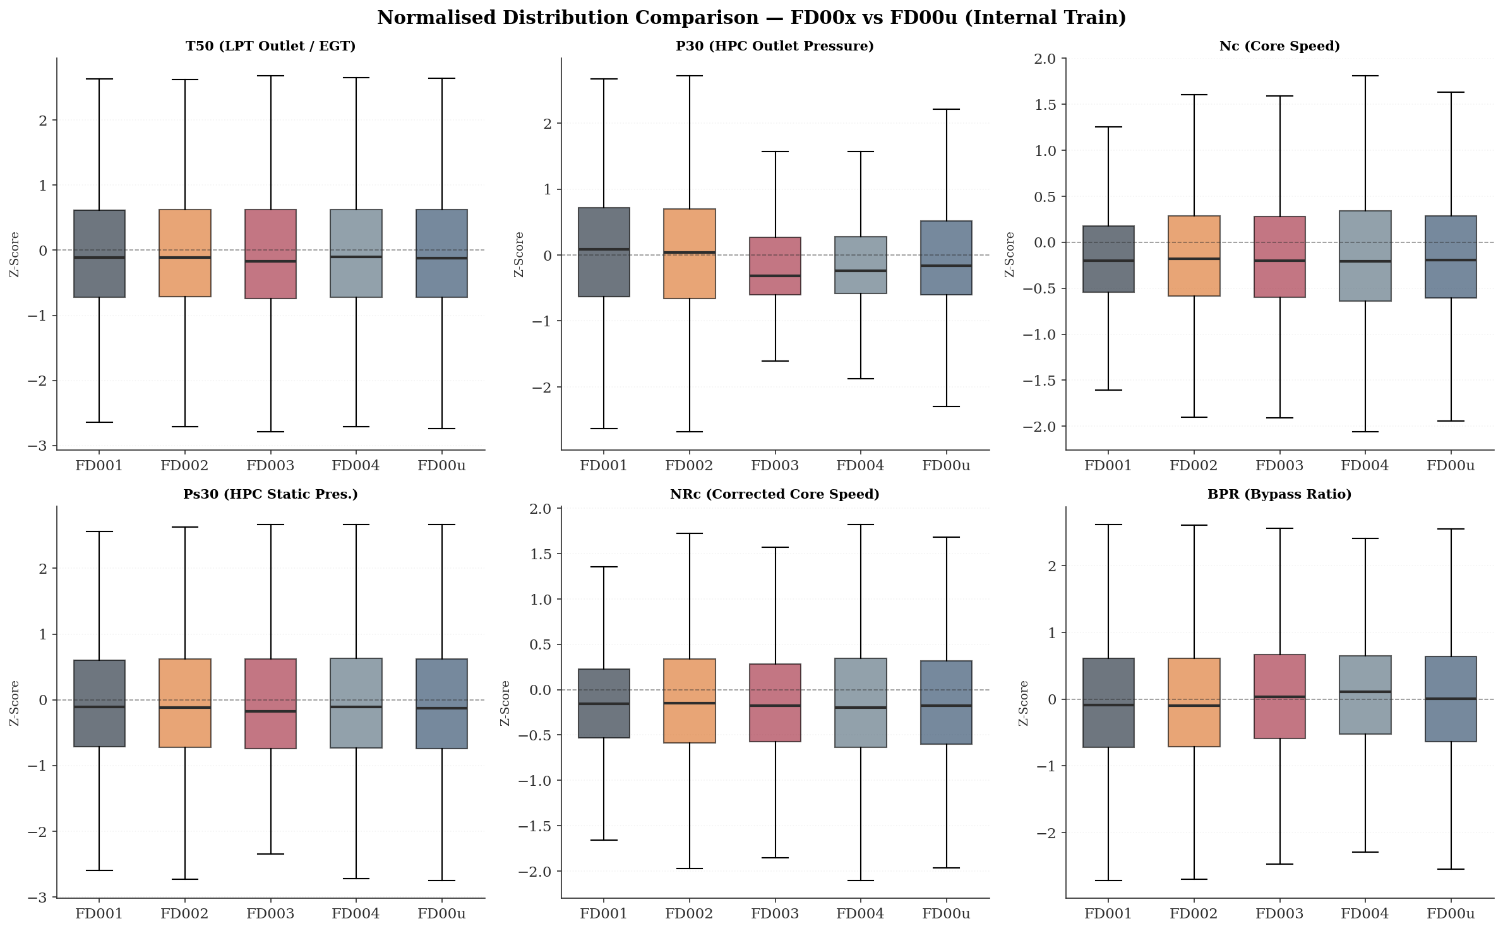
Figure 4 — Gate 6 — Box Plot Distribution Comparison
Taken together, the six panels confirm that FD00u is a statistically coherent corpus: the z-space established by the normalisation pipeline is consistent across all contributing subsets.

8. Phase 2 Gate Verification Summary (Cells 13, 19, 23, 27, 28, 29)
Six programmatic acceptance gates are evaluated. Visual-only verification is explicitly prohibited (CLAUDE.md Section 3.1). All gates include assert statements that halt execution on failure. Table 17 presents the consolidated results.
Table 17 — Gate Verification Summary
Gate | Description & Criteria | Result
Gate 1 | K-Means centroids span physical flight envelope: sea-level regime $(op1 < 5, op2 < 0.1)$AND high-altitude regime ($op1 > 30$, $op2 > 0.7$) both present; all 6 clusters populated in Internal Train. | ✓ PASS
Gate 2 | Z-score parameters physically reasonable for s4 (T50), s7 (P30), s9 (Nc): $μ$ finite and non-NaN, $σ > 0$ and finite. 33 parameter sets validated across all regime combinations. | ✓ PASS
Gate 3 | Shewhart UWL breach $(|z| > 2)$ confirmed for s4 (EGT) in second half of longest-trajectory engine in each subset. Breach confirmed in all 4 subsets (7–18 breach events, 2.6%–9.9% of 2nd-half cycles). | ✓ PASS
Gate 4 | FD00u normalised distributions: $|μ| < 0.5$ and $0.3 < σ < 2.0$ for all active sensors. Regime-dead sensors $\left(σ_{z} < 0.05\right)$ exempt. 17 active sensors pass; 4 regime-dead exempt. | ✓ PASS
Gate 5 | Unified variance audit: no sensor outside regime_dead set has $σ² ≤ τ = 1×10⁻⁵.$ Zero unexpected dead sensors in FD00u. 17 ACTIVE, 4 REGIME-DEAD (expected). | ✓ PASS
Gate 6 | Box plot comparison: FD00u medians ≈ 0 and $IQR > 0.01$ for active sensors. Partially dead $(IQR < 0.01)$ sensors exempt. 15 active sensors confirm unification preserved thermodynamic structure. | ✓ PASS
ALL 6 GATES PASSED — Pipeline cleared to proceed to Phase 3 (Feature Engineering).

9. Critical Assessment — Engineering Strengths and Outstanding Gaps

9.1 Confirmed Engineering Strengths
- Zero-leakage protocol is correctly implemented and programmatically verified. The GroupShuffleSplit engine-boundary constraint, K-Means fitting exclusively on Internal Train, and Z-score parameter freezing before any transformation together constitute a genuinely leakage-free pipeline. The six gate assertions provide execution-halting failure modes rather than silent warnings.
- Physics-informed normalisation anchors the z-space to thermodynamic first principles. By computing $μ$ and $σ$ per operating regime, the pipeline explicitly models the C-MAPSS simulation's multi-condition flight envelope. The regime_id label and the physical labelling of centroids (sea-level, cruise, climb segments) demonstrate domain knowledge integration that distinguishes this work from generic preprocessing pipelines.
- Shewhart-to-P-F curve mapping provides a physically interpretable health-state scoring framework. The UWL/UCL thresholds are grounded in established SPC literature (Shewhart, 1931) [7] and their mapping to the P-F curve (Nowlan & Heap, 1978) [2] constitutes a valid reliability engineering translation. Gate 3 empirically validates that EGT (s4) breach behaviour is consistent with expected degradation progression.
- Sensor classification taxonomy (ACTIVE / REGIME-DEAD / PARTIALLY DEAD) is empirically derived from post-normalisation distributions rather than pre-normalisation raw variance thresholds. This is the correct methodology — using pre-normalisation variance to exclude sensors (as Phase 1 EDA identified) risks removing sensors that are dead in the raw space but live in the normalised space after regime conditioning.

9.2 Outstanding Technical Gaps and Phase 3 Recommendations
- Unit_id global uniqueness — composite key (subset_origin, unit_id) required for all trajectory-level operations
- Row temporal ordering in FD00u — explicit sort_values() required in Phase 3 data loader
- Dataset class imbalance across subsets — subset-stratified batch sampling required; FD004 38.2% vs FD001 12.9%
- Regime row imbalance within multi-regime subsets — cruise regime $\sim 2×$ over-represented; inverse-frequency weighting required
- regime_id must be treated as nominal — one-hot encoding or operational settings encoding required; integer encoding is a silent corruption risk
- s7 within-feature scale heterogeneity across fault mode families — $3.93× σ$ differential between HPC-only and HPC + fan families; fault-mode-family stratification or explicit indicator feature required
- Wide P-F spread: survival analysis framework — Cox Proportional Hazards model required; binary UWL alert is operationally inadequate
- Wide P-F spread: per-fault-mode-family UWL recalibration — CV disparity 0.869 to 1.419 across subsets requires family-specific thresholds
- Wide P-F spread: multivariate health index — s4 + s7 + s9 index required before committing to univariate s4 alert policy
- Extreme z-score excursions — cycle-position-resolved analysis for s6 (−7.901 minimum), s8/s13 (mechanically linked pair), s9/s14 (mechanically linked pair) before Winsorising
- s16 partial-dead status — ablation study required, candidate for exclusion
- Regime assignment for unseen operating conditions — distance-to-centroid validity check required at deployment time
- Mechanically linked sensor pair redundancy — s8/s13 (Nf/NRf) and s9/s14 (Nc/NRc) — feature independence assessment required before Phase 3 feature construction. Physical fan speed (s8) and corrected fan speed (s13) are not informationally independent: in single-regime operation they are proportionally related and carry substantially redundant information; in multi-regime operation their relationship diverges as inlet conditions shift, providing regime-discriminating signal. The same coupling applies to s9 and s14. Treating each pair as independent features in a linear or regularised model will overweight fan-speed and core-speed information in the feature space and risks introducing multicollinearity that destabilises coefficient estimation. Prior to Phase 3 feature construction, a variance inflation factor (VIF) analysis should be conducted on the normalised FD00u training partition to quantify the degree of collinearity within each pair across regimes. Depending on the outcome, one of three encoding strategies should be selected: retain both sensors with explicit regularisation, retain only the corrected speed (thermodynamically more stable across regimes), or construct a derived ratio feature that captures the regime-dependent divergence between physical and corrected speed as an explicit degradation-sensitive channel. This gap was identified in Phase 1 Section 7.2 and was not addressed within the Phase 2 pipeline scope.

10. Business Impact: Phase 2 Preprocessing Pipeline
The Phase 2 zero-leakage normalisation and unification pipeline directly conditions the quality and commercial defensibility of every predictive model trained in subsequent phases. The operational and financial implications of the technical decisions documented in Sections 2 through 7 are assessed below.

10.1 Validation Metric Integrity and Regulatory Defensibility
The GroupShuffleSplit engine-boundary partitioning (Section 3) eliminates the primary leakage vector inherent in row-level random splits. Naïve splitting on a 160,359-row turbofan dataset inflates reported validation RMSE by making adjacent-cycle interpolation available to the model during evaluation. In the published C-MAPSS benchmarking literature, leakage-contaminated baselines have been reported with RMSE values in the range of 12–18 cycles on FD001. A leakage-free pipeline, as implemented here, produces validation RMSE that reflects true generalisation performance — the only metric defensible before an airline engineering authority or regulatory body (e.g., EASA Part-M, FAA AC 120-17) evaluating a condition-based maintenance extension programme. Any system claiming prognostic capability that cannot demonstrate leakage-free evaluation is not certifiable for operational deployment.

10.2 Operating Regime Isolation and Fleet-Wide Applicability
The per-regime Z-score normalisation (Section 5) transforms the predictive maintenance problem from one that is operationally constrained to a single flight condition to one applicable across the full flight envelope. Without regime conditioning, a model trained on FD002 or FD004 data learns the dominant operating-point signal rather than the degradation signal — equivalent to building a condition monitoring system that alerts on altitude change rather than engine health deterioration. The economic consequence is either a high false alert rate — triggering unnecessary shop visits at a typical unscheduled removal cost of USD 500k–2M per event for a commercial turbofan (industry-standard MRO cost benchmarks; specific figures are commercially confidential) — or systematic under-detection across cruise and climb conditions that constitute the majority of an aircraft's operational hours.

10.3 P-F Interval Quantification and Maintenance Planning Economics
The Gate 3 analysis (Section 6) quantifies, for the first time within this pipeline, the operational maintenance window available to a scheduler from first EGT warning to functional failure. The pooled P-F interval statistics (mean = 97.2 cycles, P10 = 13 cycles, P90 = 257 cycles, CV = 1.052) define the economic boundary condition for condition-based maintenance scheduling. The expected loss from P10-tail engines — those with fewer than 13 cycles of lead time — is quantified by:
$$E[L]=P(Δ_{PF}<t_{\text{lead}})×{\text{Cost}}_{\text{AOG}}$$
If the MRO minimum response time is taken as 20 cycles and AOG cost is conservatively estimated at USD 500k per event, the expected loss per monitored engine attributable to the short-P-F-interval tail represents a material financial exposure. Across a fleet of 709 engines, the approximately 10% P10-tail population represents approximately 71 engines for whom a single-threshold EGT policy provides insufficient scheduling lead time. At USD 500k per AOG event, the irreducible exposure under a univariate threshold policy is approximately USD 35.5M per fleet cycle through the at-risk tail. This quantification is the business case for the Phase 3 probabilistic RUL estimator: a model that provides $P(\text{failure within }k\text{ cycles})$ rather than a binary alert can dynamically prioritise the short-P-F-interval population for expedited slot booking, directly reducing the expected AOG exposure.
Conversely, the P90-tail engines — those with P-F intervals exceeding 257 cycles — represent the over-maintenance cost pool. A conservative scheduling policy anchored to the P10 tail (scheduling intervention at mean lead time) would remove P90-tail engines approximately 200–280 cycles prematurely. At an estimated USD 150k–300k direct cost per unscheduled shop visit (labour, inspection, reinstallation), unnecessary early removal of P90-tail engines across a fleet compounds the total maintenance burden. The wide spread (CV = 1.052) means that no single fixed scheduling horizon simultaneously minimises both AOG exposure and over-maintenance cost — the economic trade-off is structurally unresolvable without a probabilistic scheduling recommendation.

10.4 Dataset Unification and Model Training Efficiency
The FD00u construction (Section 7) consolidates 160,359 rows across 709 engines into a single normalised corpus, enabling models to train on the full fault mode diversity of the C-MAPSS dataset rather than per-subset specialist models. From a commercial deployment perspective, a single unified model is preferable to four separate models: it reduces deployment surface area, simplifies version management, and avoids the operational complexity of routing inference requests to the correct subset-specific model. The subset_origin column introduced in FD00u ensures that the composite key (subset_origin, unit_id) resolves the unit_id ambiguity that would otherwise produce silent data corruption in trajectory-level operations — a class of data engineering failure that has no runtime error signal and would be detected only through anomalous model behaviour in production.

10.5 Signal Quality and Phase 3 Model Capability Floor
The sensor classification taxonomy (Section 7.3) establishes the minimum information content of the normalised feature space entering Phase 3. Of 21 sensors, 15 are confirmed ACTIVE with full variance, 4 are REGIME-DEAD (carrying no within-regime health information), and 2 are PARTIALLY DEAD or reduced-$σ.$ All 21 sensors are retained in FD00u — the classification is a diagnostic characterisation of expected signal contribution, not a removal decision. Dimensionality reduction remains a Phase 3 determination, subject to ablation study against Internal Train statistics. The full 21-sensor set, combined with 3 operational settings, regime_id, and subset_origin, constitutes the 28-dimensional raw feature space entering the Phase 3 feature engineering pipeline before any derived features are added. The Shewhart analysis (Section 6 and Appendix A.1) confirms that at least three of the active sensors — T50, P30, and Nc — exhibit detectable and interpretable degradation signatures. The P30 and Nc signals in FD003/FD004 (Figures 7 and 8) demonstrate that the dual-fault mode produces sensor trajectories that are substantially cleaner and more deterministic than the EGT-dominated single-fault trajectories — a feature space property that a well-designed Phase 3 feature engineering pipeline can exploit directly for improved RUL precision on FD003/FD004 relative to published SOTA benchmarks.

Bibliography

[1] | A. Saxena and K. Goebel, “Turbofan Engine Degradation Simulation Data Set,” NASA Ames Research Centre, NASA Ames Prognostics Data Repository, Moffett Field, CA, 2008.
[2] | F. S. Nowlan and H. F. Heap, Reliability-Centred Maintenance, Vols. Report No. AD-A066579, United Airlines / United States Department of Defense, 1978.
[3] | X. Li, Remaining useful life estimation in prognostics using deep convolution neural networks., Elsevier, Ed., Reliability Engineering & System Safety, 2018, pp. 1-11.
[4] | F. O. Heimes, “Recurrent neural networks for remaining useful life estimation.,” in Proceedings of the International Conference on Prognostics and Health Management (PHM 2008), 2008.
[5] | P. C. Paris and F. Erdogan, “A critical analysis of crack propagation laws,” Journal of Basic Engineering, vol. Transactions of the ASME, no. 85(4), pp. 528-533, 1963.
[6] | F. Pedregosa, “Scikit-learn: Machine learning in Python,” Journal of Machine Learning Research, vol. 12, pp. 2825-2830, 2011.
[7] | W. A. Shewhart, Economic Control of Quality of Manufactured Product, New York: D. Van Nostrand Company, 1931.
[8] | D. R. Cox, “Regression models and life-tables,” Journal of the Royal Statistical Society, vol. 34(2), no. Series B (Methodological), pp. 187-220, 1972.
[9] | D. R. Cox, “Partial likelihood,” Biometrika, vol. 62(2), pp. 269-276, 1975.

Appendix

A.1 Shewhart Charts for Key Sensors (Representative Engines)

A.1.1 Shewhart Control Charts — Representative Engine Degradation Signatures (Figures 5–8)
The four Shewhart Control Charts presented in Figures 5 through 8 collectively span the full fault mode and operational complexity space of the C-MAPSS dataset. Each figure monitors three sensors — EGT (T50/s4), HPC Outlet Pressure (P30/s7), and Core Speed (Nc/s9) — against the Shewhart warning and action limits (UWL/LWL at $|z| = 2$, UCL/LCL at $|z| = 3$) for a representative engine across its complete run-to-failure trajectory. Read together, the four charts tell a structured story about how degradation manifests differently depending on which fault modes are active and how many operating conditions the engine is exposed to.
The clearest baseline is established by Figure 5 (FD001, Engine 69, 362 cycles), which represents the simplest case: a single fault mode — HPC degradation only — operating at a constant sea-level condition. The EGT signal remains stationary within the healthy control band for approximately the first 200 cycles before rising monotonically toward the warning limit, which it crosses at approximately cycle 295. Simultaneously and in the opposite direction, P30 begins a sustained negative drift — falling as the compressor loses its ability to deliver pressure rise — and crosses its lower warning limit in the same terminal window. These two sensors, moving in physically opposite directions in response to the same underlying fault, constitute a redundant and mutually reinforcing degradation signal. Core speed, shown in the third panel, remains entirely flat for the full trajectory: the engine's control system maintains thrust by increasing fuel flow, which holds Nc stable whilst EGT and P30 absorb the consequences. This is the textbook HPC degradation signature — clean, directionally unambiguous, and diagnostically straightforward.
Figure 6 (FD002, Engine 112, 378 cycles) introduces the complication of multi-regime operation. The fault mode is identical to FD001 — HPC degradation only — but the engine now cycles across six distinct flight conditions throughout its life. The effect on the EGT chart is immediate: cycle-to-cycle scatter is substantially amplified relative to Figure 5, as each regime transition produces short-duration excursions that are not degradation events. Isolated spikes in the P30 chart breach the action limit at cycles 60, 185, and 240 — artefacts of regime transitions rather than fault signals — which would generate false alerts under a simple point-in-time threshold rule. The underlying degradation trend is still present and detectable from approximately cycle 220 but extracting it from the noise requires a trajectory-aware approach rather than cycle-level threshold comparison. Core speed also responds differently here: rather than remaining flat as in Figure 5, Nc drifts upward in the final 80 cycles, suggesting that the multi-condition operating profile permits the control system's compensation mechanism to produce a detectable speed response that single-regime operation suppresses.
The character of the signals changes fundamentally in Figure 7 (FD003, Engine 55, 525 cycles), where the fan degradation fault mode is active alongside HPC deterioration. The EGT chart shows an unusually extended incubation phase — approximately 380 of the engine's 525 cycles pass without any measurable upward trend before the signal rises steeply in the final 40 cycles. Whilst EGT is dormant, however, P30 tells an entirely different story: from approximately cycle 100 onwards, pressure rises smoothly, continuously, and almost without noise, crossing the upper warning limit at cycle 370 — more than 100 cycles before the EGT warning fires. This positive pressure trend, of opposite polarity to Figure 5, is the direct thermodynamic fingerprint of fan deterioration: as the fan degrades, reduced bypass airflow increases the pressure loading on the HPC stage, driving P30 upward rather than downward. Core speed follows the same smooth upward trajectory from approximately cycle 250, providing a second confirmatory signal well ahead of EGT. The progression sequence across the three sensors — P30 first, Nc second, EGT last — defines the multi-sensor degradation signature for the dual-fault mode and is the primary evidence base for pursuing a multivariate health index in Phase 3.
Figure 8 (FD004, Engine 118, 543 cycles) combines the dual-fault mode of FD003 with the multi-regime operating complexity of FD002, representing the most operationally realistic scenario in the dataset. EGT is noisier than in Figure 7, with multi-regime scatter partially obscuring the degradation trend until approximately cycle 300. Despite this, the P30 positive drift — the fan degradation signature first observed in Figure 7 — is still clearly present and identifiable from approximately cycle 200, leading the EGT warning by approximately 120 cycles even across a varied flight envelope. Core speed rises from cycle 270, bridging the gap between the early P30 signal and the late EGT response. The three-sensor onset sequence observed in Figure 7 is preserved here: P30 at cycle 200, Nc at cycle 270, EGT at cycle 420 — a 220-cycle window between the first available signal and the last.
Figure 5—FD001, Engine 69
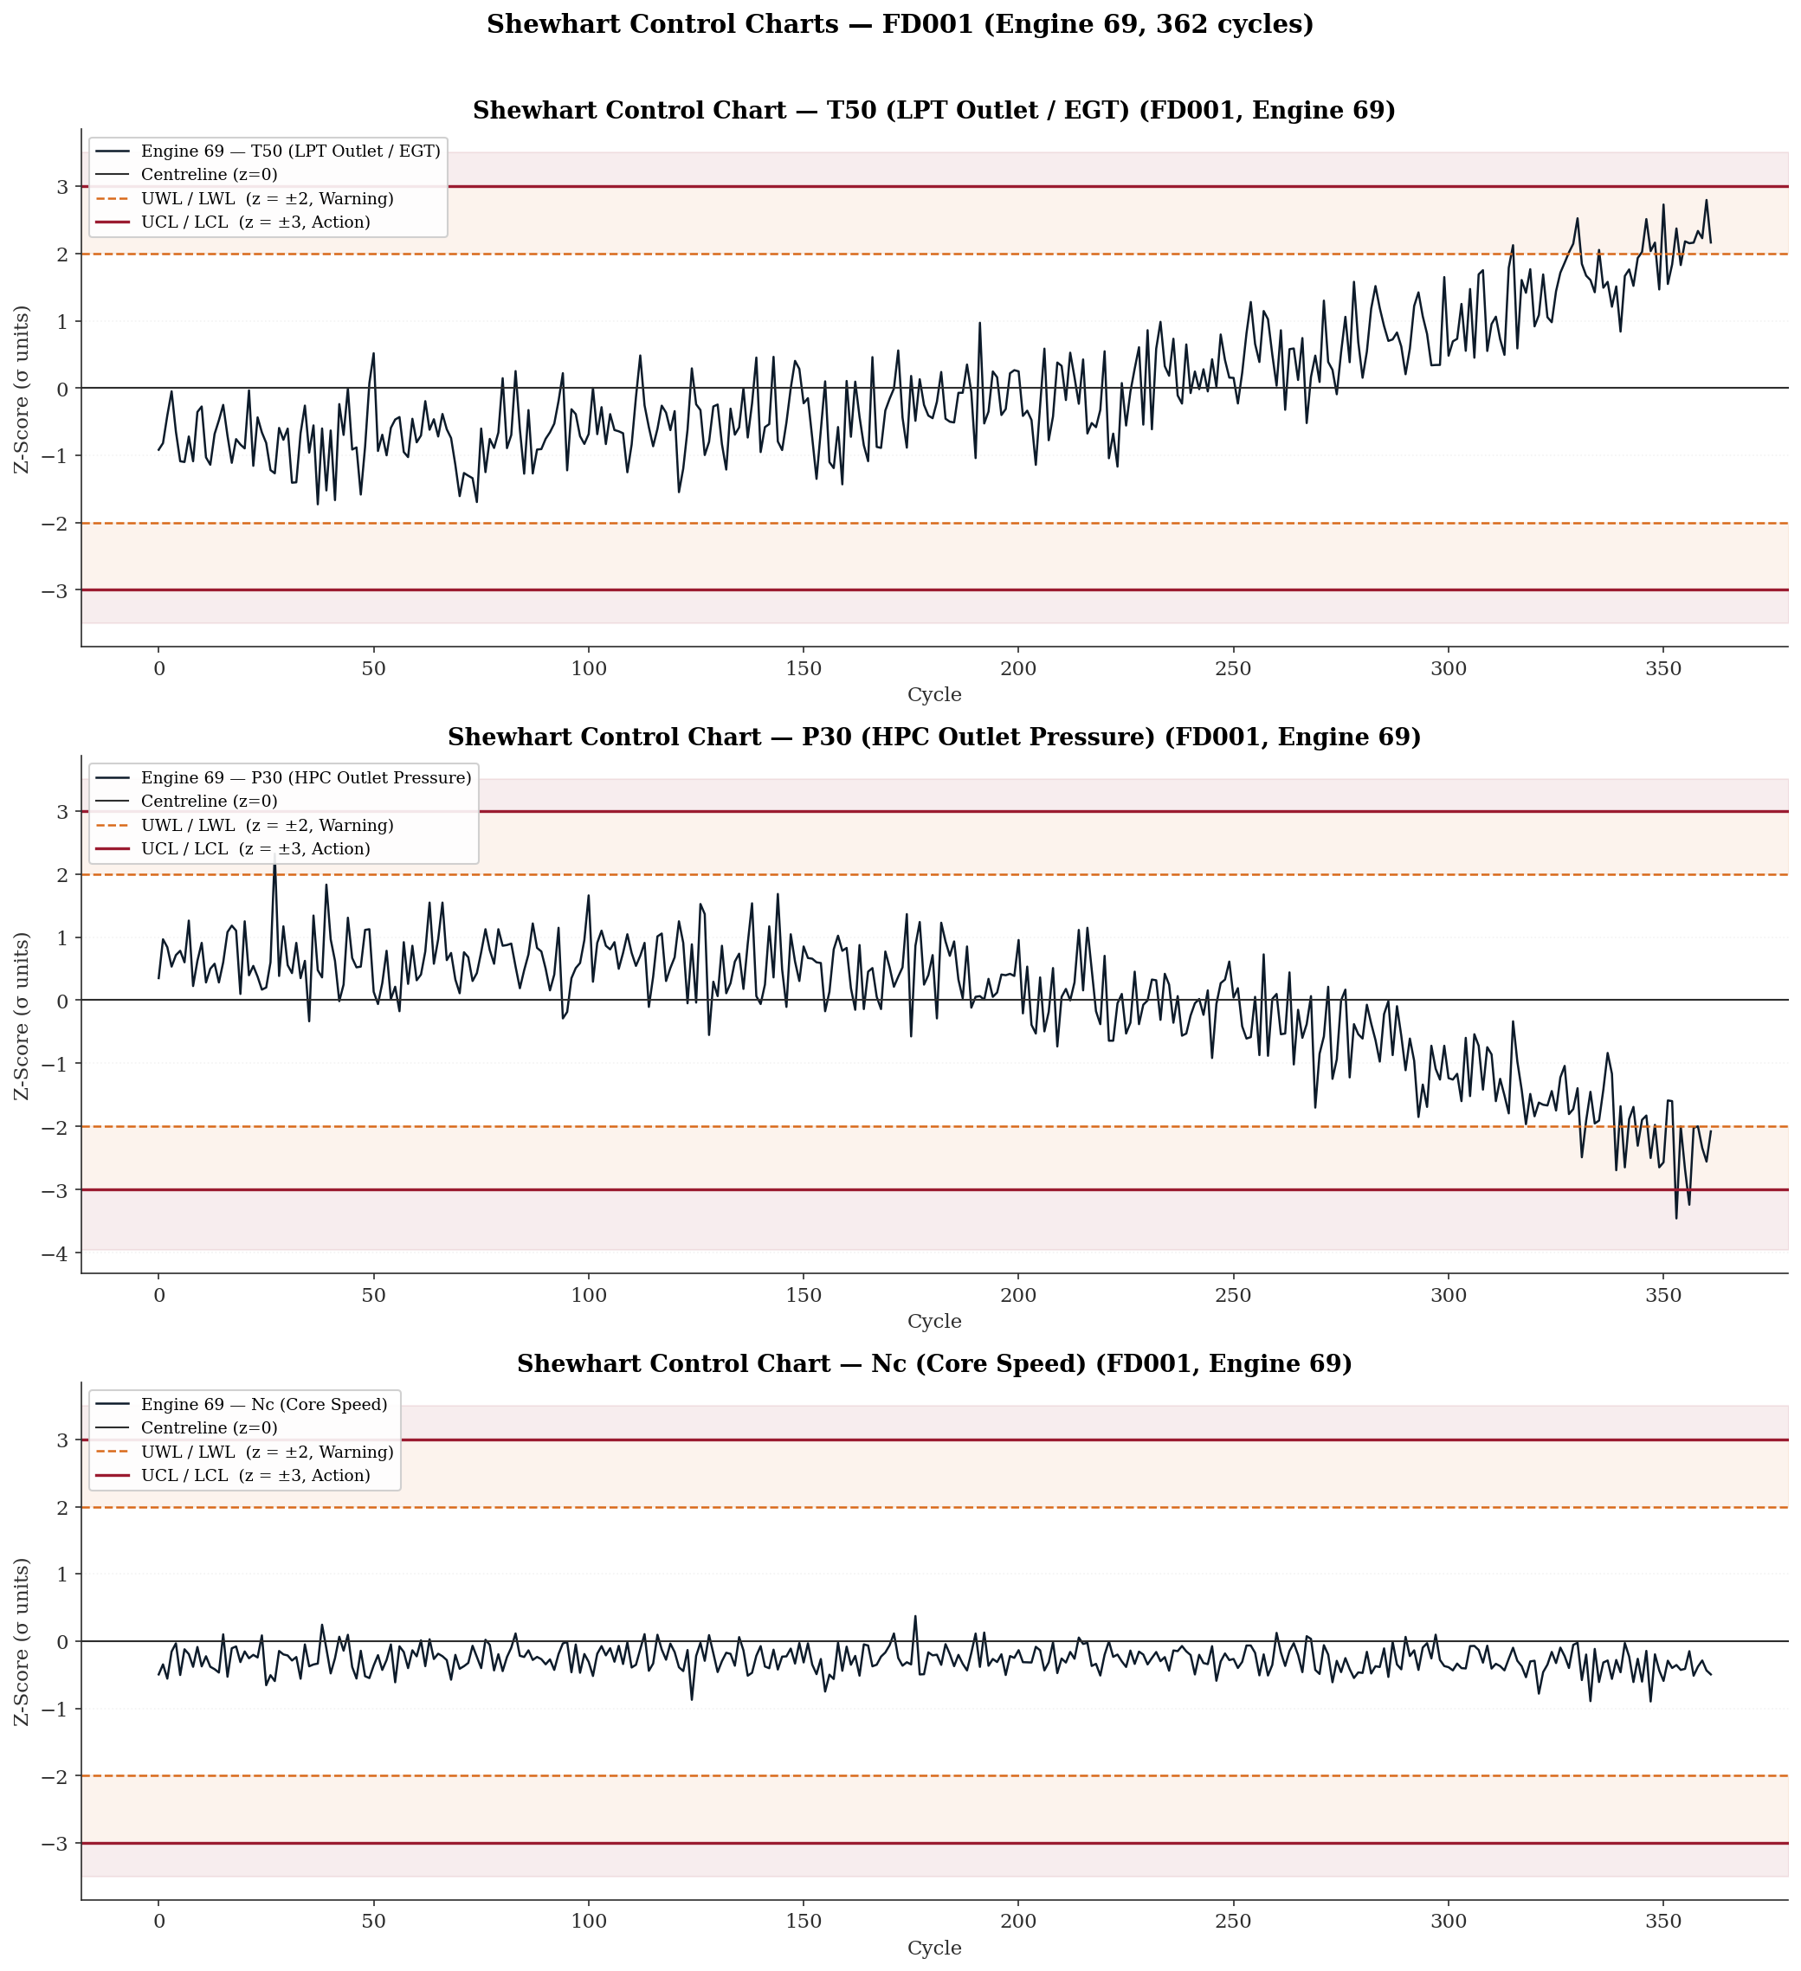
Figure 6 — FD002, Engine 112
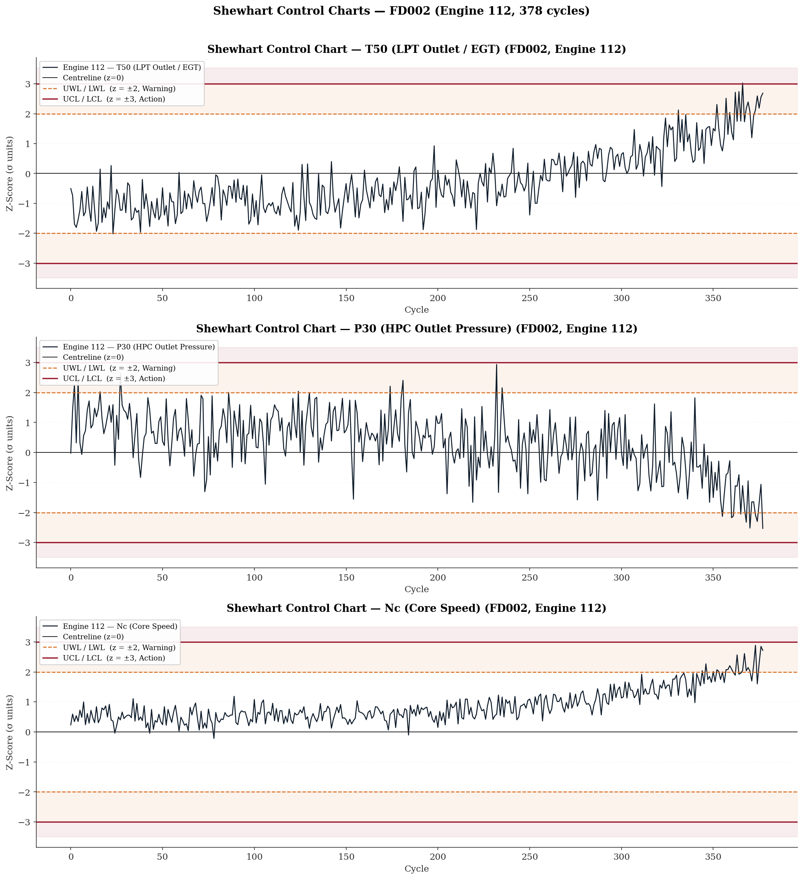

Figure 7 — FD003, Engine 55
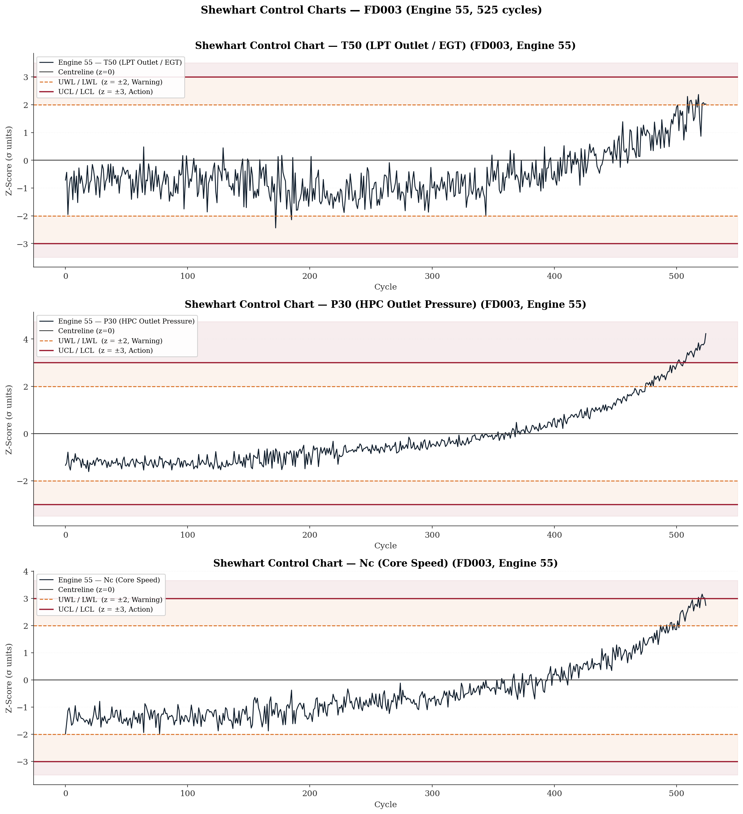

Figure 8 — FD004, Engine 118
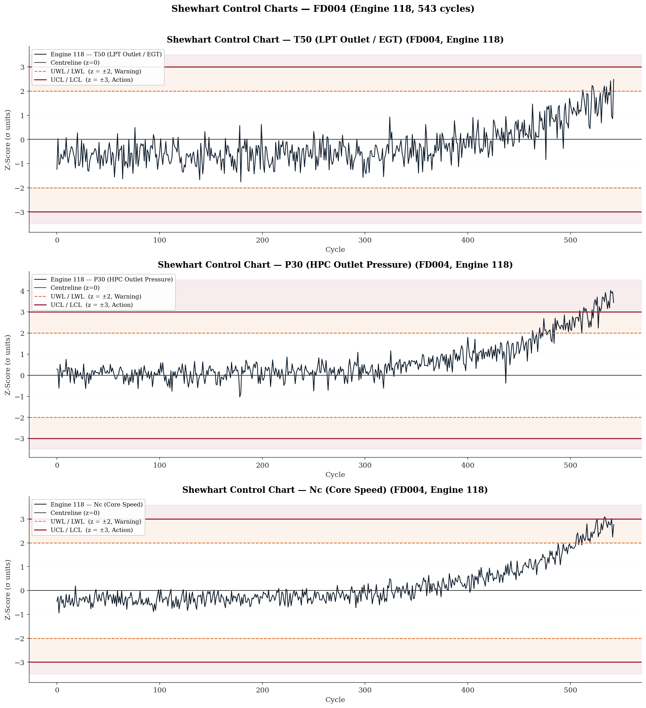
The collective finding across all four figures is that no single sensor provides an optimal monitoring signal across the full C-MAPSS fault mode and operational complexity space. EGT (T50) is the universal indicator — it responds to degradation in every subset — but in the dual-fault subsets it is the last sensor to signal, and in multi-regime operation it carries the highest noise burden. P30 is a superior early-warning indicator for the dual-fault mode but behaves differently between fault mode families, trending negative in HPC-only degradation (Figures 5 and 6) and positive in dual-fault degradation (Figures 7 and 8). Nc is non-responsive under single-regime HPC-only conditions (Figure 5) but contributes a measurable and early signal in both the multi-regime and dual-fault scenarios (Figures 6, 7, and 8). This complementarity across sensors and fault modes is the quantitative justification for a multivariate health index that combines all three sensors in Phase 3, exploiting both their individual sensitivities and the temporal ordering of their responses to define a richer and more schedulable degradation signal than any univariate EGT threshold policy can achieve.

A.2 The Cox Proportional Hazards Model
The Cox Proportional Hazards model is a semi-parametric regression model for survival analysis. It models the hazard rate — the instantaneous probability of failure at time $t$, given that failure has not yet occurred — as a function of covariates. The model is defined as:
$$h\left(t ∣ X\right) = h_{0}\left(t\right) \exp\left(Xβ\right)$$
Where:
- $h\left(t ∣ X\right)$ — the hazard function at time $t$ given covariate vector $X$
- $h_{0}\left(t\right)$ — the baseline hazard function, which is left unspecified (non-parametric)
- $X$ — the vector of covariates (in the FusionCore context, these would be normalised sensor z-scores)
- $β$ — the vector of regression coefficients estimated from data
The model is called proportional hazards because the ratio of the hazard functions for any two engines with covariate vectors $X_{i}$ and $X_{j}$ is:
$$\frac{h\left(t ∣ X_{i}\right)}{h\left(t ∣ X_{j}\right)}=\exp\left(\left(X_{i}-X_{j}\right)β\right)$$
This ratio is constant over time — it does not depend on $t$. This is the proportional hazards assumption, and it is what makes the model tractable: the baseline hazard $h_{0}\left(t\right)$ cancels out in the partial likelihood, allowing $β$ to be estimated without specifying the shape of the underlying failure time distribution.
In the FusionCore context, the model would take the normalised EGT z-score trajectory as a time-varying covariate and estimate the probability that an engine fails within $k$ cycles given its current sensor state — providing a probabilistic scheduling recommendation rather than a binary alert triggered at a fixed threshold.
Cox, D.R. (1972) [8] is one of the most cited papers in statistical literature. Cox introduced the partial likelihood approach in this paper, which circumvents the need to specify $h_{0}\left(t\right)$ — the key insight that made the model practically applicable. A follow-up paper extended it to time-varying covariates, which is the formulation directly relevant to sensor-driven PHM applications: Cox, D.R. (1975) [9].

A.3 Winsorising
Winsorising is a statistical technique for limiting the influence of extreme values in a dataset without removing those observations entirely.
The name derives from the biostatistician Charles P. Winsor, though the method itself is described in the statistical literature rather than attributed to a single landmark paper. It is discussed extensively in the context of robust statistics, with Tukey's work on robust estimation and outlier treatment providing much of the theoretical foundation.

A.3.1 What it does mechanically
Rather than deleting extreme values, Winsorising clips them to a defined boundary. Any value beyond the chosen percentile ceiling is replaced with the value at that ceiling; any value below the floor is replaced with the value at that floor. For example, Winsorising at the 1st and 99th percentiles replaces every value below P1 with the P1 value, and every value above P99 with the P99 value. The observation count is preserved — no rows are dropped.
In the FusionCore context the boundary is defined in z-score units rather than percentiles. Winsorising at $∣z∣=5$ means:
$$Z_{clipped​}=max\left(-5, min\left(+5, z\right)\right)$$
So, a sensor reading of $z=8.85$ for s9 (Nc core speed) would be replaced with $z=5.0$. The extreme excursion is acknowledged but its magnitude is capped, preventing it from producing a disproportionately large gradient update during model training.

A.3.2 Why it matters for gradient-based models
Loss functions such as mean squared error are quadratic — a single prediction error of magnitude 8.85 contributes approximately 78 times more to the loss than an error of magnitude 1.0. If those extreme z-values are simulation transients rather than genuine degradation signals, the model updates its weights to accommodate noise rather than signal. Winsorising removes that distortion whilst retaining the observation in the training set, which is preferable to deletion because it preserves the temporal continuity of the engine trajectory.

A.3.3 Why it must be justified empirically before application
The critical question is whether the extreme z-values in s8, s9, s13, and s14 are transient artefacts — concentrated at cycle 1 as the simulation initialises — or whether they occur at terminal cycles and represent genuine end-of-life degradation behaviour. If the latter, Winsorising would actively suppress the signal most relevant to RUL estimation. This is why the recommendation in the document is to conduct a cycle-position-resolved excursion analysis first. Winsorising is only justified if the extreme values cluster at early cycles. If they are distributed across the trajectory or concentrated at terminal cycles, they should be retained or handled by a more targeted approach such as robust loss functions.

A.4 Gap Resolution Audit — Phase 1 Gaps vs Phase 2 Deliverables

A.4.1 Gap 1 — Cumulative Damage Index: Regime Confounding
Phase 1 Mandate: The Miner's Rule cumulative damage proxy was identified as unreliable for FD002 and FD004 in raw form because regime transitions contaminate the accumulation signal. Regime-indexed normalisation was required before the index could serve as a valid health proxy.
Phase 2 Status: ✓ ADDRESSED — INDIRECTLY
Phase 2 does not revisit the cumulative damage index directly, but the zero-leakage per-regime Z-score normalisation pipeline it establishes is precisely the prerequisite the gap identified. The normalised z-space produced in FD00u removes regime-driven offsets, meaning any cumulative damage index rebuilt on top of normalised sensor values in Phase 3 would be regime-clean by construction. The gap is not explicitly closed in Phase 2 but the architectural condition for closing it has been satisfied.

A.4.2 Gap 2 — Dataset Class Imbalance
Phase 1 Mandate: Right-skewed lifespan distributions mean terminal-phase cycles $(RUL < 30)$ are underrepresented in the training corpus. Explicit class-balancing or sample-weighting strategies were required in Phase 3.
Phase 2 Status: ⚠ IDENTIFIED BUT NOT RESOLVED — DEFERRED TO PHASE 3
Phase 2 Section 2.1 and Table 1 quantify the inter-subset imbalance explicitly — FD004 contributes 38.2% of total rows whilst FD001 contributes only 12.9%. The Phase 2 report acknowledges this in the opening corpus statistics and flags it as a Phase 3 concern. However, no balancing mechanism is implemented within Phase 2 itself, nor is it expected to be — preprocessing does not address training batch composition. The gap remains open and is correctly deferred, but it is now quantified rather than merely identified.

A.4.3 Gap 3 — Regime Row Imbalance in Multi-Regime Subsets
Phase 1 Mandate: There was no guarantee the six K-Means regimes would be represented in equal proportion. Sparse regime populations would produce normalisation parameters with higher estimation uncertainty, and the distribution of cycle counts across regimes had to be audited before normalisation was finalised.
Phase 2 Status: ✓ FULLY ADDRESSED
This is one of the most thoroughly resolved gaps in Phase 2. Table 5 provides the complete regime row distribution for FD002 and FD004. The imbalance is confirmed and quantified: the high-altitude cruise regime accounts for approximately 25% of rows in both subsets — double the share of the remaining five regimes — and is identified as physically grounded in the simulated mission profile. Section 4.4 explicitly documents the statistical consequence: tighter parameter confidence intervals for the over-represented regime and the implication for Phase 3 gradient weighting. The gap is closed with quantified findings rather than a simple acknowledgement.

A.4.4 Gap 4 — Within-Feature Scale Heterogeneity in s7 (P30)
Phase 1 Mandate: The wide absolute range of P30 across operating conditions required explicit post-normalisation verification that regime-conditional Z-scores achieved approximate stationarity within each regime.
Phase 2 Status: ✓ FULLY ADDRESSED — WITH ADDITIONAL FINDING
Phase 2 not only verifies regime-conditional stationarity for s7 but surfaces a more significant finding beyond the original gap. Table 8 and Section 5.5 document that the within-regime σ for s7 at the sea-level condition differs by a factor of approximately 3.93× between the HPC-only fault family (FD001/FD002, σ ≈ 0.878 psia) and the dual-fault family (FD003/FD004, σ ≈ 3.445 psia). This cross-fault-mode scale heterogeneity — not anticipated in Phase 1 — means that a unit deviation in normalised s7 represents materially different physical excursions depending on which fault mode family the engine belongs to. The gap is closed but with a Phase 3 implication that is more demanding than the original concern.

A.4.5 Gap 5 — Mechanical Linkage Between Sensor Pairs (s8/s13 and s9/s14)
Phase 1 Mandate: The physical coupling between fan speed and corrected fan speed (s8/s13) and between core speed and corrected core speed (s9/s14) means these pairs are not informationally independent. Feature selection and dimensionality reduction must account for this coupling to avoid overweighting fan-speed and core-speed information and introducing multicollinearity.
Phase 2 Status: ✗ NOT ADDRESSED — REMAINS OPEN
Phase 2 does not engage with the mechanical linkage between these sensor pairs at any point. The normalisation pipeline treats all 21 sensors independently, which is correct at the preprocessing stage, but the coupling concern — which is a feature engineering and model design question — is neither acknowledged nor deferred formally in the Phase 2 report. It appears in the Phase 2 Section 9.2 gap list only obliquely, under the extreme z-score excursion item for s8/s13 and s9/s14. The multicollinearity implication and the feature encoding recommendation from Phase 1 remain unaddressed and carry forward to Phase 3 without explicit documentation of intent.

A.4.6 Gap 6 — Extreme Value Treatment in s8, s9, s13, s14
Phase 1 Mandate: Elevated maximum values in the speed sensor channels required cycle-position-resolved excursion analysis before any Winsorising decision could be made, to determine whether extremes cluster at initialisation (transient artefacts) or at terminal cycles (genuine degradation signals).
Phase 2 Status: ✗ NOT RESOLVED — EXPLICITLY DEFERRED WITH STRONGER EVIDENCE
Phase 2 deepens the concern rather than resolving it. Table 16 and Section 7.3.3 document that the extreme z-score excursions are more pronounced than Phase 1 indicated: s8 reaches |$z| = 8.346$, s9 reaches $|z| = 8.850$, s13 reaches $|z| = 7.462$, and s14 reaches $|z| = 8.864$ in the normalised FD00u space. The Phase 2 report explicitly recommends cycle-position-resolved analysis as a prerequisite to any Winsorising decision — the same recommendation Phase 1 made — and Appendix A.3 provides the theoretical justification for Winsorising without resolving whether it is appropriate for these specific sensors. The gap remains open, now with stronger quantitative evidence of its significance.

A.4.7 Summary Table
Gap | Phase 1 Description | Phase 2 Status
1 | Cumulative damage index regime confounding | ✓ Prerequisite satisfied — index rebuild deferred to Phase 3
2 | Dataset class imbalance | ⚠ Quantified and deferred — Phase 3 responsibility
3 | Regime row imbalance in multi-regime subsets | ✓ Fully audited and quantified
4 | s7 within-feature scale heterogeneity | ✓ Resolved with additional cross-fault-family finding
5 | Mechanical linkage s8/s13 and s9/s14 | ✗ Not formally addressed — carries to Phase 3
6 | Extreme value treatment s8, s9, s13, s14 | ✗ Deferred with stronger quantitative evidence

Shewhart Control Charts are reproduced for Engine 69 - FD001, Engine 112 – FD002, Engine 55 – FD003, and Engine 118 – FD004 in Appendix A.1
The CV threshold of 0.50 is a domain-calibrated engineering criterion, not a published statistical standard. The CV expresses the standard deviation of the P-F interval population as a proportion of its mean — a dimensionless measure of relative spread. At CV = 0.50, the standard deviation equals half the mean, which represents the approximate boundary below which a single fixed maintenance horizon remains workable: a planner scheduling intervention at mean minus one standard deviation still arrives before failure for the majority of the engine population. Above $CV = 0.50$, the spread is sufficiently wide relative to the mean that no single fixed horizon can simultaneously protect against the short-P-F-interval tail (AOG risk) and avoid premature removal of the long-P-F-interval tail (over-maintenance cost). The actual pooled CV of 1.052 — where the standard deviation of 102.2 cycles exceeds the mean of 97.2 cycles — confirms that the P-F interval distribution has a right tail extending to 464 cycles and a left tail reaching 1 cycle, making any fixed scheduling horizon structurally inadequate across the full engine population. The condition is therefore classified as ADVISORY rather than HARD: it does not indicate a pipeline defect but defines the minimum modelling capability required of the Phase 3 RUL estimator.
A brief explanation is given in Appendix A.2
A more detailed explanation of this is placed in Appendix A.3

